**Hemostasis/Thrombosis And Anticoagulation**

Table of Contents

Basics of Hemostasis 5

Primary hemostasis 5

Basics 5

Components 5

Secondary Hemostasis 6

Tertiary hemostasis 6

Fibrinolysis 6

PAI-1 inhibits tPA 6

Coagulation Cascade 7

Basics 7

Vitamin K Dependent Factors 7

Repletion 7

PT and PTT – The Tests 7

PT 7

PTT 7

Overview 7

The mechanics of the test 8

Pathways 8

Overview 8

Classic Pathways 9

Intrinsic 9

Extrinsic 9

Convergence 9

In Vivo (three major phases) 9

Initiation 9

Amplification 9

Thrombin 9

Propagation 10

Multicomponent Complexes 10

Overview 10

Extrinsic X-ase (ten-ase) 10

Intrinsic X-ase (ten-ase) 10

Prothrombinase 10

The protein C anticoagulant complex 11

Basic Coagulation Work Up 13

PT and PTT 13

Factor Deficiencies 13

Coagulation Tests 14

Thrombin time 14

Uses of Thrombin Time 14

Reptilase Time 14

Dilute Russell Viper Venom Test (dRVVT) 15

Mixing Study 15

Basics 15

Logistics 15

Thromboelastography 15

Overview 15

Uses of TEG 15

Clinical Presentation 15

liver disease and Hemostasis 16

Putting in a CVC 16

Role of cryoprecipitate 16

Role of FFP 16

Liver Dz vs. Vit K Deficiency 16

Measure Factor V 16

Increased Factor VIII 16

Inherited Factor Deficiencies 18

Factor VII 18

Basics 18

Clinical presentation 18

Treatment 18

Fibrinogen Deficiency (Factor I) 18

Basics 18

Clinical Presentation 19

Treatment 19

Factor XI Deficiency 19

Overview 19

Management 19

Emergency 19

Factor XII Deficiency 20

Factor XIII Deficiency 20

Anti-thrombin III deficiency 20

Acquired Inhibitor/Acquired Hemophilia 21

Basics 21

Diagnosis 21

Management 21

Factor V Leiden 23

Overview 23

Abnormalities In Fibrinolysis 25

Arterial Thromboembolism 26

Overview 26

Risk Factors for Arterial Thromboembolism 26

Artificial Heart Valves 26

Pregnancy 27

Postransplantation Erythrocytosis (PTE) 27

Essential Thrombocytosis 27

No Proven Associations 27

Prothrombin Gene Mutation 27

Anti-thrombin III Deficiency 27

Arteriovenous Graft Thrombosis 27

Overview 27

Potential Pharmacologic Interventions to Prevent AVG Thrombosis or Failure 28

Overview 28

Immediate graft thrombosis 28

Evaluation for hypercoagulable state 28

Anticoagulation 29

Data 29

Antiplatelet Agents 29

Evaluation of “Unexplained” arterial Thromboembolism 31

Warfarin 32

History 32

Discovery 32

Initial Warfarin Dosing 33

General Considerations 33

Dosing 33

Chronic Warfarin Dosing 35

Warfarin Reversal 35

Overview 35

Prothrombin Complex Concentrates 37

Overview 37

Prothrombin Complex Concentrate 37

Overview 37

Advantages 37

Contraindications 37

DIC 37

HIT 38

Activated PCC 38

Overview 38

AEs 38

Heparin 39

Overview 39

Unfractionated versus Low-molecular-weight heparin 39

Monitoring Heparin 39

Overview 39

Heparin Resistance 40

Management 40

Overview 40

Thrombate 40

Heparin Infusion Using Anti-Xa Monitoring 40

Provider-Managed Protocol - AntiXa Monitoring 40

Heparin Activity (AntiXa) Level 41

PRN Re-Bolus 41

Change Infusion Rate 41

Next Heparin Activity (AntiXa) Level 41

NoACs – Non-VKA Oral AntiCoagulant 43

Overview 43

Challenges with Warfarin 43

Properties of Ideal Long-Term Anticoagulant 43

Coagulation Cascade 43

Overview of Atrial Fibrillation Management 45

Epidemiology 45

Data for Anticoagulation in Atrial fibrillation 45

Overview 45

Dabigatran (Pradaxa) in AF 46

Data 46

Dosing 46

Renal Adjustment 46

Rivaroxaban (Xarelto) 46

Indications 46

Data 46

Dosing 46

Treatment of VTE 46

VTE Prophylaxis 47

Renal Dosing 47

Apixaban (Eliquis) 47

Dosing 47

Renal Adjustments 47

Edoxaban (Lixiana) 47

Data in AF 47

Dosing 48

Renal Adjustments 48

Mega’s Summary 48

Total Hip and Knee Replacements 48

VTE and PE 48

ACS And Antithrombic Therapy 49

Data for NOACs in Cancer 50

Data 50

SELECT-D Trial7 50

Summary 50

Overview 50

Results 50

Hokusai Trial8 51

Overview 51

Results 51

Summary 52

Other Data with NOACs in Cancer 52

Barrier to the use of NOACs and VKAs (Vit K antagonists) 52

Renal Dosing 53

Renal Clearance 53

Apixaban 53

Adverse Effects 54

When to be cautious or don’t use (per Bauer) 54

NoACs vs. Warfarin 54

Ischemic Strokes 54

Intracranial Hemorrhage 54

Major Bleeding 54

GI Bleeding 54

Major GI Bleeding 54

Life-Threatening or Fatal GI Bleeding 55

Mortality Reduction 55

Cost-Effectiveness 55

Reversal Agents 55

Idarucizumab (PraxBind) for Dabigatran Reversal 55

Andexanet 56

Managing Bleeding On A Noac 56

Overview 56

Perioperative Management Of Anti-Coagulation 58

Overview 58

Risk Stratifying 58

Transitioning from Warfarin 59

Bridging Patients on Warfarin 60

Peri-operative management of NoACs 61

Restarting Anticoagulation 61

Warfarin 61

Heparin 62

NoACs 62

Managing patients with fluctuating INRs 62

Management of Antiplatelets 62

Transition of Anticoagulants 64

References 68

# Basics of Hemostasis

## Primary hemostasis

### Basics

* The hemostatic process often is divided into three phases:
  + The vascular
  + Platelet
  + Plasma phases
* When blood is exposed to **subendothelium**, a platelet plug forms within seconds
  + Depends on **collagen** below the endothelium, **cognate receptors on platelets** (Gp Ib/IX/V) and **von Willebrand factor** (adhesion)
  + Platelets are activated by binding of surface receptors for collagen, ADP, thromboxane A2 (release reaction), and thrombin (but there isn’t much thrombin at the start)
    - **Dense granules**
      * The dense granules of human platelets contain adenosine diphosphate (ADP), adenosine triphosphate (ATP), ionized calcium (which is necessary for several steps of the coagulation cascade), histamine and serotonin
    - **Alpha granules**
      * Contents include insulin-like growth factor 1, platelet-derived growth factors, TGFβ, platelet factor 4 (which is a heparin-binding chemokine) and other clotting proteins (such as thrombospondin, fibronectin, factor V, and von Willebrand factor)
        + A deficiency of alpha granules is known as gray platelet syndrome
  + Platelet-platelet interactions (Gp IIb/IIIa) and fibrinogen (aggregation)

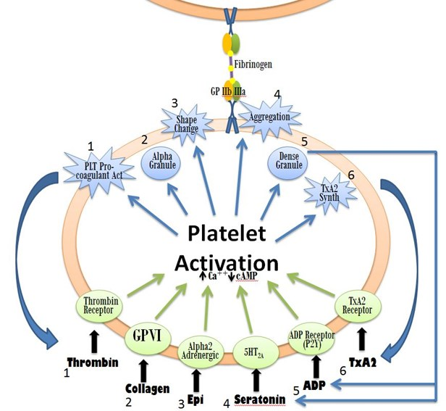

### Components

* Vessel wall
* Platelets
  + Expresses GpIb/IX/V on it’s surface which binds to vWF
  + Express Gp VI which binds to exposed collagen
* vWF, fibrinogen
  + vWF binds collagen and GpIb/IX on platelets
    - Bernard-Soulier Syndrome (genetic loss of GpIb/IX)

## Macintosh HD:Users:davidmiller:Desktop:Screen Shot 2015-12-01 at 9.01.37 AM.pngSecondary Hemostasis

* Activation of coagulation factors
  + Coagulation cascade
  + Activated platelets supply calcium and phospholipid surface to anchor and orient factors
* **Thrombin generation**
* Factors XI deficient patients almost never bleed, unless at surgery
* All clotting takes place on phospholipids
* Ten-ase
  + VIIIa lays down
* All clotting tests are done in **sodium citrate**
  + All tests are done in plasma, not serum
* XIII
  + Transglutaminase enzyme
    - Outside of both intrinsic and extrinsic pathway
      * Will have been nl PT and PTT
* Fibrin split products
  + Factors of fibrin and fibrinogen
* D-dimer
  + Requires

## Tertiary hemostasis

* Clot retraction
* Cross linking of fibrin monomers by Factor XIII to anchor thrombus and close large holes

## Fibrinolysis

### PAI-1 inhibits tPA

* Deficiencies can lead to hyperfibrinolysis, but the significance of mutations and thrombophilia have not been well established



# Coagulation Cascade

## Basics

### Vitamin K Dependent Factors

* II, VII, IX, X
* Protein C, S and Z
* Vitamin K is an essential factor to a hepatic gamma-glutamyl carboxylase that adds a carboxyl group to glutamic acid residues on factors II, VII, IX and X, as well as Protein S, Protein C and Protein Z
* Vitamin K deficiency can occur in the setting of biliary obstruction, since bile increases the absorption of fats, it is an important part of the absorption of the fat-soluble substances, such as the vitamins A, D, E, and K

### Repletion

* Consider repleting with Vitamin K 10mg/day PO x3 days if a patient is able to take POs, otherwise 10mg IV as a single dose

## Pathways

### Overview

* In real life, *in vivo*, coagulation **starts along the extrinsic arm** (with tissue factor binding to VIIa)
* It progresses down the final common pathway (making some Xa, some thrombin, and finally a little fibrin)
* Then – for some reason – the extrinsic arm gets turned off.
  + Yes, turned off!
    - This actually happens as soon as you make a little Xa (see the figure to the right)
  + Xa interacts with **tissue factor pathway inhibitor** (TFPI) and turns off the extrinsic arm
* By that point, though, there’s enough thrombin around to kick off coagulation along the intrinsic arm (the one with XI, IX and VIII) – and from there on out, the intrinsic arm supplies the rest of the fibrin.
* To summarize: coagulation starts with the extrinsic arm.
  + As soon as you make a little Xa, the extrinsic arm is turned off.
  + The small amount of thrombin that has been generated during the action of the extrinsic system goes up and turns on the intrinsic arm, which finishes out the job of making the rest of the fibrin. Weird, but true.

### Classic Pathways

#### Intrinsic

* 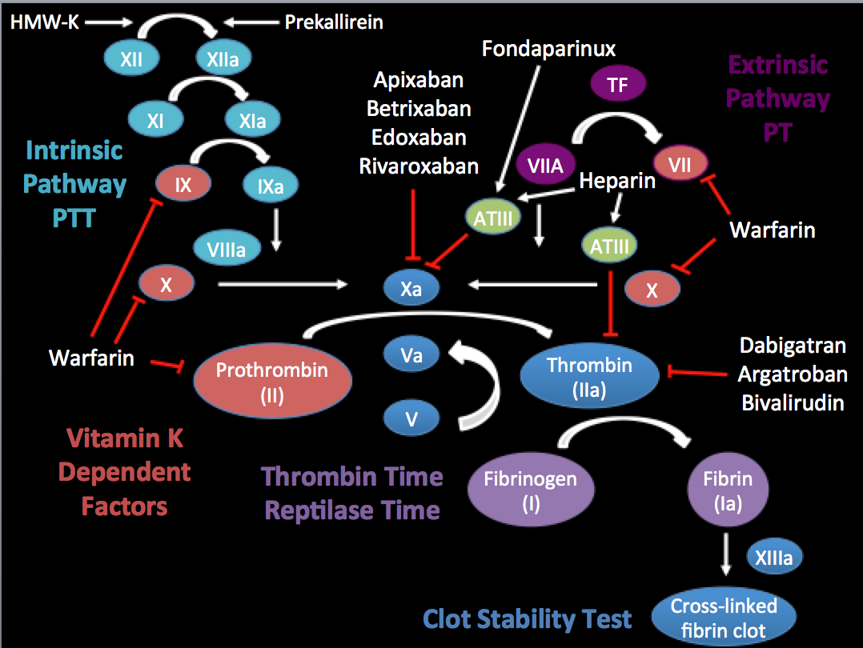Initiated by the **exposure** of **blood to a negative charge surface**
  + Celite
  + Kaolin
  + Or silica (in the in vitro activated partial thromboplastin clotting time (aPTT)
* High-molecular-weight kininogen (HMW-K) is a circulating plasma protein which participates in the initiation of blood coagulation, and in the generation of the vasodilator bradykinin via the kallikrein-kinin system
  + HMWK is also a precursor of bradykinin

#### Extrinsic

* Activated by **Tissue Factor** or a tissue factor-like material (thromboplastin, TPL)
  + Exposed at the site of injury
  + TPL, used in the in vitro prothrombin clotting time (PT)

#### Convergence

* Both pathways converge on the activation of factor X which, as a component of prothrombinase, converts prothrombin to thrombin, the final enzyme of the clotting cascade
* Thrombin converts fibrinogen from a soluble plasma protein into an insoluble fibrin clot (tested in the in vitro thrombin time [TT])
* The classic pathways are useful in explaining the results of *in vitro* clotting assays, but not necessarily what happens *in vivo*

### In Vivo (three major phases)

#### Initiation

* During initiation, damaged tissue results in the exposure of tissue factor
* TF then serves as the **cofactor** required for the production of activated factor VII
* TF then binds activated factor VIIA
  + Thus, initiation is driven by the “extrinsic” pathway, so to speak
* VIIA/TF complex then **activates** Factor IX to IXa and Factor X
  + Factor X is also activated by activated IXa
    - This dual pathway of factor X activation (ie, directly and indirectly via activation of factor IX) is necessary because of the limited amount of TF generated in vivo and the presence of the tissue factor pathway inhibitor (TFPI) which, when complexed with factor Xa, inhibits the TF/FVIIa complex
    - Thus, sustained generation of thrombin depends upon the activation of factor IX and its cofactor factor VIII
* Activated X (Xa) then produces small amounts of **thrombin** by activating prothrombin
* During Initiation, only about 5% of the overall thrombin is generated
  + The other 95% is generated by the intrinsic pathway

#### Amplification

##### Thrombin

* **Thrombin**, once generated, plays a critical role in propagating the coagulation cascade by the following:
  + Activates factor XI (XI -> XIa)
    - XIa can then contribute to more IXa production and further generation of Xa and thus more conversion of prothrombin to thrombin
  + Activates platelets via PAR receptors (protease-activated receptors)
    - Activation of platelets leads to exposed anionic phospholipids, which support the assembly of the multi-component enzyme complexes
    - Activated platelets secrete Factor V from their alpha granules
      * Of note, there are two types of factor V, platelet factor V and circulating factor V
  + Activates factor VIII
  + Activates factor V (by cleaving it)

#### Propagation

* Activated factor VIII (VIIIa) with activated factor IX (IXa), activates Xa
* Activated factor V (Va) and activated Xa, on the platelet phospholipid surface forms the **prothrombinase** complex
  + Converts one molecule of prothrombin (II) to thrombin (IIa)
* Thrombin **converts fibrinogen to fibrin**, which undergoes polymerization
* Activated factor XIII (factor XIIIa) stabilizes and crosslinks overlapping fibrin stands
  + Factor XIIIa (along with fibrinogen) also controls the volume of red blood cells (RBCs) trapped within a thrombus, which in turn controls clot size
    - Mice lacking factor XIII (or harboring a fibrinogen mutation that abrogates factor XIIIa binding) formed clots approximately one-fifth the size of those in wild type mice, due to extrusion of RBCs during clot retraction; similar findings were seen in the plasma from a factor XIII-deficient patient
    - The formation of factor XIIIa is promoted by the complexing of thrombin, fibrin, and factor XIII

### Physiology of Coagulation Factors

#### Factor X/Xa

* The serine protease Factor Xa (FXa) plays a central role in the blood coagulation, as it acts at the convergence point of the intrinsic and extrinsic coagulation pathways.
* FXa catalyzes the conversion of prothrombin to thrombin; one molecule of FXa results in the generation of more than 1000 thrombin molecules.
* Inhibition of FXa blocks this burst of thrombin- generation, thereby diminishing thrombin-mediated activation of coagulation.

### Multicomponent Complexes

#### Overview

* Four multicomponent macromolecular complexes play a major role in the coagulation pathways:
  + three procoagulant complexes
    - extrinsic X-ase
    - intrinsic X-ase
    - prothrombinase
  + one anticoagulant complex
    - protein C anticoagulant complex
* These complexes consist of the enzyme, a cofactor protein, the enzyme substrate, assembled on cellular membrane components (anionic phospholipid surfaces) in the presence of calcium
  + The calcium binding and phospholipid surfaces accelerate “ten-ase” and “prothrombinase” reactions at least 1000-fold

#### Extrinsic X-ase (ten-ase)

* Consists of activated factor VII (factor VIIa) as the protease, *tissue factor as the cofactor*, and ***factor X (Stuart factor) as the substrate***
  + The extrinsic X-ase activates both factor X and factor IX

#### Intrinsic X-ase (ten-ase)

* Consists of factor IXa as the protease, activated *factor VIII (factor VIIIa) as the cofactor,* and ***factor X as the substrate***
  + Factor IXa can be generated by the extrinsic X-ase or via activation of the intrinsic pathway, either directly or indirectly via thrombin-induced activation of factor XI.

#### Prothrombinase

* Consists of factor Xa as the protease, factor Va as the cofactor, and prothrombin (factor II) as the substrate

#### The protein C anticoagulant complex

* Consists of thrombin (factor IIa) as the enzyme, thrombomodulin as the cofactor, and protein C as the substrate. In addition, endothelial protein C receptor (EPCR), which is primarily expressed on the endothelium of large blood vessels, functions as a receptor for protein C and further accelerates the activation of protein C by the thrombin/thrombomodulin complex

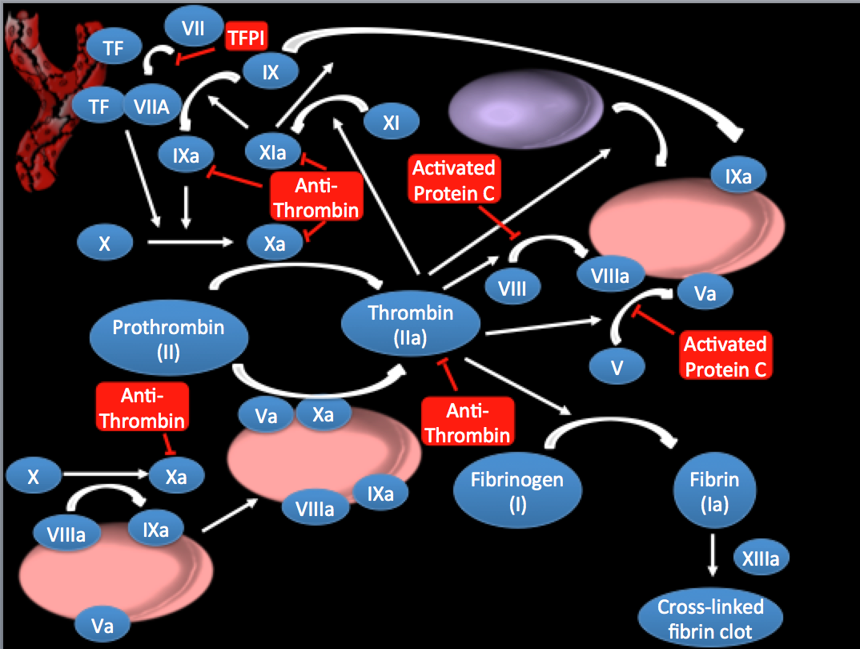



# Basic Coagulation Work Up

## 

## Coagulation Tests

### PT and PTT – The Tests

* The whole point of these two tests is to measure how long it takes for the blood to **form fibrin**
* The PT (or INR, same thing) – measures how long it takes to form fibrin using the extrinsic system, and the partial thromboplastin time (PTT) measures how long it takes to make fibrin using the intrinsic system
* To do a PT, you add something that acts like tissue factor to the blood in the test tube, and you measure how long it takes to make fibrin
  + This mimics what happens in the body: the blood gets “exposed” to tissue factor, and it progresses along the extrinsic pathway to make fibrin
* Pearls
  + polycythemia the volume of plasma to cells will be lower, and this can
  + you want 3 ml in the blue top tube to have the right amount of citrate

#### PT

* You need to add tissue factor, calcium and phospholipid to the tube of plasma in order for fibrin to form

#### PTT

##### Overview

* Partial thromboplastin time
  + The test is termed "partial" due to the absence of tissue factor from the reaction mixture.
* Thromboplastin in the body is a combination of phospholipid and tissue factor
  + Thus, the partial thromboplastin test is just the phospholipid component, free of the TF component
  + The term 'thromboplastin' in this test refers to the formation of a complex formed from various plasma clotting factors which converts prothrombin to thrombin and the subsequent formation of the fibrin clot.
* A historical name for this measure is the **kaolin-cephalin clotting time** (**KCCT**), reflecting kaolin and cephalin as materials historically used in the test
* The term 'Activated Partial Thromboplastin Time (APTT)' derives from the original form of the test (devised in 1953) in which only the phospholipid concentration of the test was controlled (as opposed to the phospholipid and the surface activator concentrations) and the name 'partial thromboplastin' was applied at the time to phospholipid preparations which accelerated clotting but did not correct the prolonged clotting times of haemophilic plasma
  + Essentially the term 'partial' means phospholipid is present but no Tissue Factor.
* The APTT is also known as:
  + Kaolin Cephalin Clotting Time (KCCT)
    - Do not confuse this with the Kaolin Clotting Time (KCT) which is a screening test for a lupus anticoagulant but which contains no Cephalin. Cephalin is a platelet phospholipid substitute.
  + And Partial Thromboplastin Time with Kaolin (PTTK).
* Historically, kaolin was used as a surface activator.
  + It binds directly to FXII resulting in surface activation to XIIa. XIIa cleaves FXI to XIa but in the absence of calcium, activation of the subsequent factors does not occur. Kaolin is rarely used when the APTT is automated as its opacity makes the optical detection of the endpoint (i.e. the formation of a fibrin clot) difficult.
  + Commonly used activators for automated analysers include **micronized silica** and **ellagic** acid
  + **Cephalin is a phospholipid substitute** that replaces platelet phospholipid in the test (remember the test uses platelet poor plasma and so requires a source of phospholipid for coagulation to occur.)

##### The mechanics of the test

* Blood is drawn into a test tube containing oxalate or citrate, molecules which act as an anticoagulant by binding the calcium in a sample (usually sodium citrate -> the blue top tube)
  + Citrate is an anticoagulant which binds calcium in the blood
* The blood is mixed, then centrifuged to separate blood cells from plasma (as partial thromboplastin time is most commonly measured using blood plasma)
* A sample of the plasma is extracted from the test tube and placed into a measuring test tube.
* Next, an excess of **calcium** (in a phospholipid suspension) is mixed into the plasma sample (to reverse the anticoagulant effect of the oxalate or citrate enabling the blood to clot again)
* Finally, in order to activate the intrinsic pathway of coagulation, an **activator** (such as **silica**, **celite**, **kaolin**, **ellagic** **acid**) is added, and the time the sample takes to clot (make fibrin) is measured optically
  + These compounds act as a platelet substitute
  + However, kaolin is not a phospholipid
* Some laboratories use a mechanical measurement, which eliminates interferences from lipemic and icteric samples.

#### Anticoagulant Effects on the PT/PTT

##### Xa Inhibitors

* Although one would expect that Xa inhibitors should prolong both the PT and the PTT, in the real world there are idiosyncracies 2/2 PK/PD realities, e..g
  + Rivaroxaban typically prolongs the PT more than PTT
    - Ken says that isolated PT in an 80 year old, all comers, is probably on Riva
  + Apixaban doesn’t prolong either in the real world
* However, if you overdosed someone with either, you’d probably get prolongation of both

##### Direct Thrombin Inhibitors

* Dabigatran prolongs PTT more so than PT

|  |  |  |  |
| --- | --- | --- | --- |
| **PT (Extrinsic)** | **PTT (Instrinsic)** | **Inherited** | **Acquired** |
| High | Normal | * Factor VII deficiency | * Vitamin K deficiency (mild) * Liver Disease (early; probably b/c VII plays such a critical role) * Warfarin (unless INR high) * Early DIC * Acquired VII inhibitor * Rivaroxaban (but not apixaban) |
| Normal | High | * Hemophilia A (Factor VIII deficiency) * Hemophila B (IX) * vWD (if factor VIII <50%) (inherited variety) * Contact factor deficiencies (Factor XII, XI, HMW-K, Prekallikrein) | * Inhibitor   + - Nonspecific (lupus AC)     - Specific (i.e. factor VIII inhibitor)     - Other rare inhibitors: XI * Acquired vWF (Decrease in Factor VIII levels from acquired von Willebrand Deficiency ) * Heparin * Dabigatran (doesn’t prolong PT as much) |
| High | High | * Factor X deficiency * Prothrombin deficiency * Factor V deficiency * Dysfirbrinogenemia/   Hypofibrinogenemia | * DIC (when Fibrinogen <100) * Vitamin K deficiency (severe) * Liver Disease (advanced) * Warfarin (supartherapeutic) * Inhibitor (factor V, thrombin, APLS (less commonly)) * Medication (Xa inhibitiors, Direct Thrombin Inhibitors) * Primary amyloidosis-associated factor X deficiency |
| Normal | Normal | * Factor XIII deficiency | * Factor XIII Inhibitor |

#### Coagulation FActors and the PT and PTT

* PT/PTT are generally sensitive in identifying a clinically relevant factor deficiency

|  |  |  |  |  |  |
| --- | --- | --- | --- | --- | --- |
| **Coagulant** | **Hemostasis** | **Level for**  **normal PT** | **Level for**  **normal PTT** | **Half-Life**  **(hours)** | **Plasma Levels**  **(μm)** |
| Fibrinogen (I) | 50-100mg/dl | 100mg/dL | 60mg/dL | 96-150 (4-5 d) | 7.6 |
| Prothrombin (II) | 20-30% | 50% | 15% | 42-72 (3 d) | 1.4 |
| Factor V | >20% | 50% | 15% | 24-36 | 0.03 |
| Factor VII | >10%  (15-20% Anish) | 50% | -- | 4-6 | 0.01 |
| Factor VIII | >40% | -- | 35% | 12 | 0.00003 |
| Factor IX | >30% | -- | 20% | 21-30 | 0.09 |
| Factor X | >20% | 60% | 25% | 27-48 | 0.17 |
| Factor XI | >50% (variable) | -- | 20% | 60-80 | 0.03 |
| Factor XII | 0 | -- | 20% | 24 h |  |

* Normal Levels
  + Normal Factor VIII: Normal plasma activity is 50%-150% (0.5-1.5 IU/mL)
* Therapeutic Warfarin
  + Jason said that INR of 2-3 gives you about 20% levels of prothrombin
* Epidemiology
  + Factor VIII is the most common inhibitor in elderly
* Of note, one explanation I heard for why Heparin does not prolong the PT is that the PT reagent(s) contain a positively charged molecule, polybrene that will neutralize UFH
  + <http://m.asheducationbook.hematologylibrary.org/content/2012/1/460.full>
  + Polybrene is a positively charged material that will neutralize UFH, and this is a component of many clot-based reagents. Polybrene is added to the majority of PT reagents
    - Added to PT reagents, they can neutralize up to 2 U/mL of heparin
    - However, the presence of excess heparin (eg, a sample collected shortly after a heparin bolus, through a heparin-coated catheter, or above thesite of heparin infusion) may overwhelm the heparin neutralizer and prolong the PT
  + PT only requires a small amount of thrombin to get initiation
  + You still have enough VIIa to activate the PT (Jeff’s explanation)

### Mixing Study

#### Basics

* Differentiate factor deficiency vs. inhibitor
* Factor deficiencies should correct completely
  + b/c as the above chart demonstrates, you don’t need much to get a normal level on PT or PTT
* If it does not correct completely, then an inhibitor is present
* Mixing study and inhibitor screen is the exact same thing
  + Time 0 (is an immediate time, not a pre-mix time) and Time 3-4 hours is typically
    - Incubation is critical to not miss an inhibitor
* Prolonged PTT is the most common reason to do a mixing study, but prolonged PT is becoming more commonly utilized

#### Logistics

* Mix Dilutions 1:1 of patient plasma with normal plasma
  + Incubate 2h at 37C
    - Individual factor assays performed (Factor VIII, IX, IX, XII)
      * Readout
        + The inhibitor titer in Bethesda Units is the reciprocal of the dilution that leads to 50% inhibition of activity

i.e. a 1:8 dilution would = 8 bethesda units

the higher the units the more inhibitor present

* + Need to talk to a human to get the test done urgently, it can get done
  + Can be done over the weekend
  + Draw 6 frozen hold?

### Thrombin time

* The TT measures the final step of the clotting pathway, the conversion of fibrinogen to fibrin
* The test is performed by recalcifying citrated plasma in the presence of dilute bovine or human thrombin and recording the time (in seconds) for a clot to form
* The following conditions cause a prolongation of the TT
  + **Anticoagulants** including heparin, direct thrombin inhibitors (eg, bivalirudin or argatroban), or heparin-like compounds (eg, danaparoid)
  + The presence of fibrin/fibrinogen degradation products
  + Hypofibrinogenemia (<100 mg/dL), dysfibrinogenemia, or hyperfibrinogenemia (>400 mg/dL)
  + High concentrations of serum proteins, as occurs in multiple myeloma or amyloidosis
  + Bovine thrombin antibodies from prior exposure to bovine thrombin (only when tested using bovine thrombin reagent; TT will be normal if tested using human thrombin reagent)
* It is **prolonged** with heparin use

#### Uses of Thrombin Time

* Used b/f lab does a mixing study:
  + if positive then the usually won’t do it b/c it’s likely the sample was contaminated by heparin and it will make the mixing study uninterpretable
* I’ve seen Reed use it to assess dysfibrinogenemia
  + He says that the thrombin time shouldn’t be prolonged (d/t hypofibrinogenemia) until fibrinogen is <100
  + Thus, if you have a fibrinogen > 100 and a prolonged TT, consider dysfibrinogenemia
  + If this is the case, consider transfusing cryoprecipiate to replenish functional fibrinogen E.g. in a patient with bleeding
  + Of note, TT is affected by heparing, but reptilase time is not

### Reptilase Time

* Reptilase is an enzyme similar to thrombin that is found in the venom of Bothrops snakes
* However, it differs from thrombin by generating fibrinopeptide A, but not fibrinopeptide B, from fibrinogen and by ***resisting inhibition by heparin*** via antithrombin (AT)
  + Resistant to ATIII
* The RT is similar to the TT in measuring the conversion of fibrinogen to fibrin
* The RT is useful for **detecting abnormalities in fibrinogen** (in which case the TT is also prolonged) and in detecting the presence of heparin (heparin will cause prolongation of the TT but not RT)
  + ***Thus, the RT is most useful for determining if heparin is the cause of a prolonged TT*** and in evaluation of dysfibrinogenemia
* Similar to heparin, direct thrombin inhibitors prolong the TT but not the RT
  + Inadvertent presence of a direct thrombin inhibitor is less likely to be clinically relevant, but RT could be used to test for this possibility

### Dilute Russell Viper Venom Test (dRVVT)

* A coagulation test that is highly sensitive for antibodies to beta-2-GP-1
* *Bottom line: not all patients with a LAC with have a prolonged aPTT, thus you may miss it - > solution, do a dRVVT, which is more sensitive (patients with a LAC will have an* ***abnormal*** *dRVVT)*
* This in vitro diagnostic test is based on the ability of the *venom of the Russell's viper to induce thrombosis*

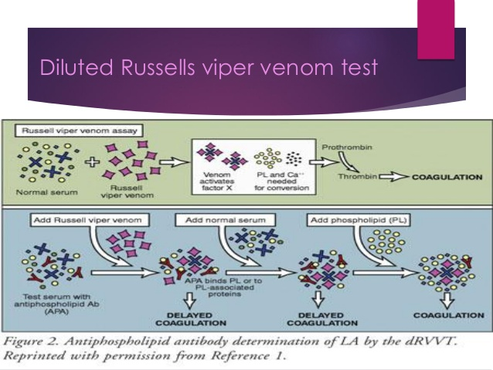

* + The coagulant in the **venom directly activates factor X**, which turns prothrombin into thrombin in the presence of factor V and phospholipid
  + In the dRVVT assay, low, rate-limiting concentrations of both Russell's viper venom and phospholipid are used to give a standard clotting time of 23 to 27 seconds
  + This makes the *test sensitive to the presence of lupus anticoagulants*, because these antibodies interfere with the clot-promoting role of phospholipid in vitro, and their presence results in a **prolonged clotting time**
  + A mixing study is then performed, which consists of adding an equal volume of the patient's plasma to normal plasma
  + *In this study, one would expect the clotting time to return to the normal range if there was only a deficiency of coagulation factors alone*
  + A prolonged clotting time of 30 seconds or greater that does not correct despite the mixing study suggests the presence of a lupus anticoagulant
    - An abnormal result for the initial dRVVT assay should be followed by a dRVVT **confirmatory test**
      * In this test, the inhibitory effect of lupus anticoagulants on phospholipids in the dRVVT can be overcome by adding an excess of phospholipid to the assay
      * The clotting times of both the initial dRVVT assay and confirmatory test are normalized and then used to determine a ratio of time without phospholipid excess to time with phospholipid excess
      * In general, a ratio of greater than 1.2 is considered a positive result and implies that the patient may have antiphospholipid antibodies
      * The dRVVT test has a higher specificity than the aPTT test for the detection of lupus anticoagulant, because it is not influenced by deficiencies or inhibitors of clotting factors VIII, IX or XI

### Mixing Study

#### Basics

* Differentiate factor deficiency vs. inhibitor
* Factor deficiencies should correct completely
  + b/c as the above chart demonstrates, you don’t need much to get a normal level on PT or PTT
* If it does not correct completely, then an inhibitor is present
* Mixing study and inhibitor screen is the exact same thing
  + Time 0 (is an immediate time, not a pre-mix time) and Time 3-4 hours is typically
    - Incubation is critical to not miss an inhibitor
* Prolonged PTT is the most common reason to do a mixing study, but prolonged PT is becoming more commonly utilized

#### Logistics

* Mix Dilutions 1:1 of patient plasma with normal plasma
  + Incubate 2h at 37C
    - Individual factor assays performed (Factor VIII, IX, IX, XII)
      * Readout
        + The inhibitor titer in Bethesda Units is the reciprocal of the dilution that leads to 50% inhibition of activity

i.e. a 1:8 dilution would = 8 bethesda units

the higher the units the more inhibitor present

* + Need to talk to a human to get the test done urgently, it can get done
  + Can be done over the weekend
  + Draw 6 frozen hold?

### Thromboelastography

#### Overview

* This is a point of care test that uses whole blood to determine specific coagulation parameters such as
  + R time (time from start of test to clot formation)
  + Maximal Amplitude (MA, maximum extent of thrombus)
  + LY30 (MA at 30 minutes, a measure of fibrinolysis

#### Uses of TEG

* Studies have shown that TEG can identify DIC by demonstrating a shorter R time (excess thrombin generation) which prolongs as coagulation factors are consumed
* The MA is decreased as fibrinogen is consumed and the LY30 shows excess fibrinolysis
* TEG has been shown to be of particular value in the management of the complex coagulopathy of trauma

### Thromboelastography

#### Overview

* This is a point of care test that uses whole blood to determine specific coagulation parameters such as
  + R time (time from start of test to clot formation)
  + Maximal Amplitude (MA, maximum extent of thrombus)
  + LY30 (MA at 30 minutes, a measure of fibrinolysis

#### Uses of TEG

* Studies have shown that TEG can identify DIC by demonstrating a shorter R time (excess thrombin generation) which prolongs as coagulation factors are consumed
* The MA is decreased as fibrinogen is consumed and the LY30 shows excess fibrinolysis
* TEG has been shown to be of particular value in the management of the complex coagulopathy of trauma

## Clinical Presentation

* History is the best screening test
* Ask about transfusion history
* Surgery is often the best screening experience
* Types of bleeding depend on the defect
  + Primary hemostatic defects
    - Bleed earlier
    - Often mild
    - Immediate bleeding
    - Mucosal bleeding (dental, nosebleeds), heavy menses, petechiae (tiny broken capillaries) +/- easy bruising
  + Secondary hemostatic defects
    - Congenital factor deficiencies cause less mucosal bleeding
      * Joint bleeds, muscles bleeds are common
      * Surgical or other internal bleeding can be severe
    - Bleeding tends to be delayed (maybe just a bit delayed); bleeding tends to be delayed in relation to surgery, trauma
* Miscellaneous
  + SQ heparin can accumulate and cause elevated PTT and supratherapeutic
  + Lupus AC
    - Don’t associate with anti-cardiolipin
  + INR vs. PT
    - Purists say you should only use INR when your discussing vitamin K antagonists
    - INR is PT patient/PT (standard) raised to exponent of 1
      * PT standard is 12 seconds
        + Thus a PT of 15 seconds responds to INR of ~1.25

## liver disease and Hemostasis

### Putting in a CVC

* Previous retrospective studies have shown that central venous catheter insertion is safe in patients with a prolonged prothrombin time and INR, including those with liver disease
* In a prospective audit of 580 internal jugular and subclavian vein cannulations in patients with chronic liver disease and an INR of 1.5 or greater, only one major vascular complication was noted

### Role of cryoprecipitate

* Cryoprecipitate is typically reserved for patients with clinically significant bleeding and a fibrinogen level less than 100 mg/dL (1.0 g/L).
* Cryprecipitate in the prophylaxis of bleeding for patients with low fibrinogen levels undergoing procedures has **not** been evaluated

### Role of FFP

* Numerous studies have shown that fresh frozen plasma (FFP) is overutilized in nonbleeding patients with mild coagulopathies, which is a significant problem given the risks associated with FFP use, including transfusion-related acute lung injury, transfusion-transmitted infection, transfusion-associated circulatory overload, allergic reactions, and hemolysis
* The role of FFP in the prevention of bleeding complications for nonbleeding patients undergoing procedures is unclear
* However, it is known that FFP is ineffective at correcting a minimally elevated INR (<1.85)

### Liver Dz vs. Vit K Deficiency

#### Measure Factor V

* Factor V is made in the liver, thus will be low in liver dz, but is not vit K dependent
  + Thus, a normal Factor V and low II, VII, IX, X if indicative of Vit K deficiency

### Increased Factor VIII

* In liver disease, all the factors are low, except Factor VIII, which is made by the endothelial cells
* In addition, good hepatic function is required for factor VIII clearance, thus, factor VIII levels are increased in liver disease

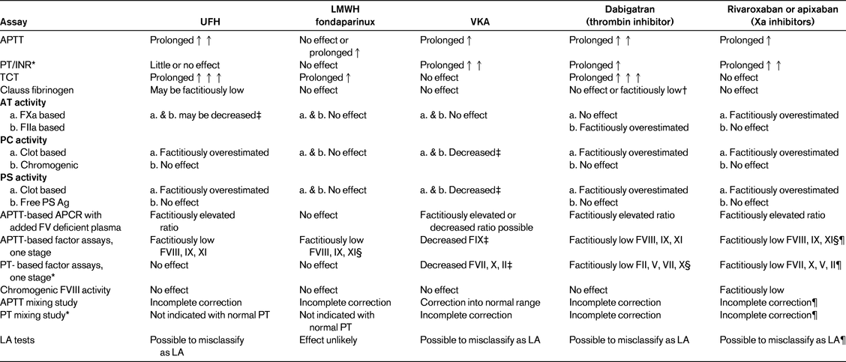

# Inherited Factor Deficiencies

## Factor VII

### Basics

* Factor VII is a serine protease
* Factor VII is produced by the liver
* Extrinsic pathway
  + Activated by Tissue Factor
  + PT
* Rare, autosomal recessive disorder
* Gene found on chromosome 13

### Clinical presentation

* Prolonged PT
* Levels do not correlate well with bleeding
* <2% of normal – can experience severe bleeding
* >10% - usually minimal or no bleeding
* VTE may complicate 3-4% of cases

### Treatment

* Do you even need to tx?
  + Bleeding itself will consume the factor and can lower the level
* First-Line
  + Recombinant VIIa (20-30ug/kg body weight) q6-8h
    - Novoseven (is recombinant fVIIa)
      * According to Ed Yoon’s talk: 15-30ug/kg, initially q2-3hrs
* Second Line
  + Prothrombin Complex Concentrates (KCentra)
    - Though not indicated for fVII repletion
    - No real data
    - Risk of thrombosis
  + FFP
    - Also no real data
* VTE management
  + Avoid warfarin
    - as you can’t really monitor it when the INR is already elevated 2/2 to the factor deficiency
    - warfarin will also cause a decrease in factor VII level so that will increase risk of bleeing
  + Go with a Xa inhibitor (regular dose)

## Fibrinogen Deficiency (Factor I)

### Basics

* Fibrinogen circulates in the plasma at a concentration of approximately 200 to 400 mg/dL, with a half-life of four days and a catabolic rate of approximately 25 percent per day
* Inherited dysfibrinogenemia
  + The result of mutations in the coding region of the fibrinogen FGA, FGB, or FGG genes
  + Approximately 100 mutations were reported to date
  + Over 90 percent are point missense mutations, leading to the production of a dysfunctional protein product
  + Autosomal dominant

### Clinical Presentation

* Prolonged PT and PTT
* Prolonged thrombin time
* Decreased clottable fibrinogen (functional test)
* Elevated Reptilase time
* Normal fibrinogen antigen level

### Treatment

* For major surgery or trauma, replace with **cryoprecipitate** to fibrinogen level >100mg/dL
* **RiaSTAP** (fibrinogen concentrate)
  + Approved for afibrinogenemia (but not dysfibrinogenemia)
  + But Bauer has used it for dysfibrinogenemia
  + Goal for procedures and situations were there is concerns for bleeding (i.e. pregnancy), the goal is fibrinogen >100
    - To calculate the dose needed use the following formula
      * Dose (mg) = [[100mg/dL – measured level (mg/dL)] / 1.7 (mg/dL per mg/kg)] x body wt (kg)
      * E.g. for a pt with a level of 64mg/dL who weight 69.1kg
        + (100mg/dL – 64mg/dL) / 1.7 mg/dL per mg/kg ] x 69.1kg

= 36/1.6 x 69.1 = 1463mg

1 Vial has ~1,141 units

* + ½ life is ~80 hours
    - check fibrinogen 15 minutes after dosing and re-dose if needed
    - then when >100, can check 6-8 hours later

## Factor VII Deficiency

Overview

* More common

## Factor XI Deficiency

### Overview

* Only contact factor deficiency a/w bleeding
* High prevalence in Ashkenazi Jews
  + Prevalence ~1:1000
* Patients may **present late in life** with no prior bleeding history (or they may have a h/o bleeding)
* Factor XI Levels
  + Heterozygotes – 15-60% of normal
  + Homozygotes/double heterozygotes - <15%
* Levels do not necessarily correlate with bleeding
  + 20-30% generally adequate for hemostasis
    - However, one study showed that the factor level a/w Grade I-III was 25%, so it’s not necessarily adequate
* Patients can have **variable bleeding** from procedure to procedure (highest with ENT and GU tract procedures)
  + Don’t do epidurals in patients with XI deficiency
    - What to do with heterozygotes is questionable
      * Heterozygotes range 25-75% factor level
    - Some docs require factor XI level to be above 70%, Bauer thinks that’s “genomic madness”

### Management

#### Emergency

* Start thawing **FFP**
  + 15-20ml/kg
* No recombinant Factor XI in US
  + It is approved in Europe

## Factor XII Deficiency

* Significantly prolonged PTT in vitro, but **no clinical bleeding** (also true for HMW-K, prekallikrein deficiency)
* These factors are not required for in vivo hemostasis
* **Requires no treatment**

## Factor XIII Deficiency

* Factor XIII deficiency (FXIII), an extremely rare disorder with a reported prevalence of one in one million in the homozygous state
* It is extremely important to diagnose it promptly because these patients tend to develop intracranial hemorrhages
* All coagulation screening laboratory tests are normal even in the presence of FXIII levels that are < 1%
* Therefore, if the disorder is suspected, the **urea clot test** (a screening test for this deficiency) should be sent
* Ideally, the deficiency should be confirmed with measurement of the FXIII antigen by an enzyme-linked immunosorbent assay (ELISA) test
* FXIII infusions in the form of **cryoprecipitate** or plasma-derived product should be infused for the treatment of FXIII-related bleeding
* Patients should be treated prophylactically with **factor concentrates** monthly infusions (FXIII half-life = 9-14 days)

## Anti-thrombin III deficiency

* + Think about in patients that fail to appropriately bump their anti-Xa levels despite therapeutic heparin
  + Think about in patients with liver failure (acquired ATIII def)

# Acquired Inhibitor/Acquired Hemophilia

## Basics

* *Typically an autoimmune reaction to Factor VIII*
  + Much less common for other factors
* Highest incidence
  + Elderly persons
  + Lymphoproliferative disorders
  + Pregnancy/post-partum
  + Medications
    - E.g. penicillin
* Potential for **life-threatening** bleeding
  + These patient’s bleed from everwhere
* Individualized treatment strategies
  + Treat underlying disorder if possible
  + rVIIa or factor (depending on Bethesda titer) for bleeding
  + Prednisone/Cyclophosphamide or Rituximab
    - We treated a patient with 125mg Cytoxan/day , 1mg/kg pred and 4 doses of Rituxan
      * Expectations that this was take ~1-2 weeks to resolve
  + Tend to resolve over time

## Diagnosis

* Mixing study
  + Mix Dilutions of patient plasma with normal plasma
    - Incubate 2h at 37C
      * Assay for Factor VIII
        + Readout

The inhibitor titer in Bethesda Units is the reciprocal of the dilution that leads to 50% inhibition of activity

i.e. a 1:8 dilution to reach 50% would = 8 bethesda units

the higher the units the more inhibitor present

* + - Logistics
      * Need to talk to a human to get the test done urgently, it can get done
      * Can be done over the weekend
      * Draw 6 frozen hold?
    - Of note, immediate normalization of PT/PTT may occur i/s/o inhibitors, b/c the kinetics are such that it takes time to get inhibition
      * Thus, if there is normalization of immediately and then prolongation at 2h, that’s pretty suggestive of an inhibitor vs. LAC, which should be prolonged initially and at 2h

## Management

* Hemostasis
  + Bypassing agents
    - Activated prothrombin complex concentrate
    - **Recombinant Factor VIIa (our go to at BIDMC)**
      * No randomized studies vs APCC
      * Typical dose: 90ug/kg q3 hours
        + 2.5h half life
      * Registry data (EACH2)
        + Baudo et al Blood 2012
      * $1000 for 1.2
        + about 6k per dose
  + Recombinant porcine factor VIII (pending FDA approval)
    - Inhibitors don’t bind as well to the porcine
* Get rid of antibody
  + GTH-AH 01/2010
    - Steroids alone (weeks 1-3)
      * Then add Cytoxan (100mg-200mg based on wt (weeks 4-6) if no CR
        + Then weekly rituximab (375mg/m2) if no CR

Starting week 7

* + - Mortality was high ~30%
      * 16 patients died of infection
      * only 3 hemorrhage deaths
  + Jeff’s approach
    - Steroids (1mg/kg)
      * If no response -> rituximab
* Prophylactic Therapy
  + Orthopedic outcomes are better in patients who have received ppx
    - Manco-johnson et al NEJM 2007
  + Start after first signficiant bleed
  + PX strategies
    - Factor VIII: 25u/kg QOD
      * Rationale
        + Convert severe to moderate hemophilia

Adjust dose to trough >2% but <5%

>2% usually removes those horrible spontaneous bleed

* + - * + Minimum dose regimen

Try weekly, if bleeding try BIW, if bleeding try TIW, etc

* + - * + Considerations

Cost of factor ($60,000 per year if 20kg)

Half life of factor

Frequency of infusions

**Random Pearls**

* Early DIC
  + PT becomes prolonged first
    - Likely 2/2 decrease in Factor VII
  + PTT and Bleeding time don’t typically get prolonged until the Fibrinogen drops below 100
* Coagulopathy and Liver Disease
  + *Increased Factor VIII*
    - In liver disease, all the factors are low, except Factor VIII, which is made by the endothelial cells
    - In addition, good hepatic function is required for factor VIII clearance, thus, factor VIII levels are increased in liver disease
* Liver Dz vs. Vit K Deficiency
  + *Measure Factor V*
    - Factor V is made in the liver, thus will be low in liver dz, but is not vit K dependent
      * Thus, a normal Factor V and low II, VII, IX, X if indicative of Vit K deficiency

# Factor V Leiden

## Overview

* Heterozygosity for the factor V Leiden mutation confers an approximately sevenfold increased risk of thrombosis, while homozygosity for the mutation increases thrombosis risk 80-fold
* In patients in whom the first episode of deep vein thrombosis (DVT) was spontaneous (idiopathic), the preponderance of evidence is that there is little difference in the incidence of recurrence, when anticoagulation is stopped, between those with or without factor V Leiden or prothrombin G20210A gene mutation, except if they have more than one thrombophilic defect (eg, heterozygous for the prothrombin gene mutation as well as factor V Leiden)
* Pregnancy
  + Women with an inherited thrombophilia should be counseled that pregnancy and the postpartum period are associated with a significantly increased risk of venous thromboembolism (VTE)
  + Estrogen-progestin contraceptives should be avoided in women with a personal history of VTE
  + IUD
    - For women with an inherited thrombophilia who want to use a long-acting reversible contraceptive (LARC), a copper-releasing intrauterine device (IUD) is the best choice for those who prioritize absence of hormonal side effects (including possible hemostatic effects) over a reduction in uterine bleeding
    - For women who want the oligomenorrhea/amenorrhea induced by progestin-only methods and are willing to accept uncertainty about a possible small increase in risk of VTE, we suggest a levonorgestrel-releasing IUD rather than the progestin-only implant because hormonal effects are primarily local (endometrium) with an IUD
  + OCP
    - Estrogen-progestin contraceptives should be avoided in women with a personal history of VTE
    - For women with an inherited thrombophilia who want to use a short-acting reversible contraceptive, we recommend a nonhormonal contraceptive method or progestin-only method over estrogen-progestin methods
    - We suggest a double barrier method (male or female condom, diaphragm) over progestin-only pills (Grade 2C) or an injectable progestin (Grade 2B)
    - Given possible prothrombotic effects of injectable progestins (depot medroxyprogesterone acetate [DMPA]) and the availability of oral progestin-only alternatives that have not been associated with increased thrombogenicity, the authors favor an oral progestin-only method rather than an injectable progestin
* *Patients with no thrombosis history* 
  + Most individuals who are heterozygous for an inherited thrombophilia without clinical thrombosis are unlikely to be aware they have a genetic defect
  + Our general approach to the management of those with laboratory-only evidence of thrombophilia is to treat them as we do the general population (ie, we do not anticoagulate them prophylactically, save for high-risk settings such as major surgery)
  + In rare cases, an individual may present with laboratory evidence of homozygosity, compound heterozygosity for an inherited thrombophilia, or a single higher risk thrombophilic defect (eg, antithrombin deficiency) without a personal thrombosis history
  + There are no data that show a benefit of long term anticoagulation in these patients, and we generally do not anticoagulate them
    - However, anticoagulation might be appropriate for such an asymptomatic individual who places an especially high value on preventing thrombosis (eg, due to massive, unprovoked pulmonary embolism in a family member)
  + Although we do not anticoagulate the vast majority of individuals with laboratory-only evidence of thrombophilia, there may be value in discussing the following issues
    - Awareness of signs and symptoms of VTE requiring prompt medical attention
    - Family history, both to clarify individual risk and to counsel regarding testing or not testing of family members
    - Prophylactic anticoagulation during high risk situations (eg, pregnancy, surgery)
    - Potential avoidance of oral contraceptives

# Abnormalities In Fibrinolysis

## Overview

* A variety of parameters of fibrinolysis have been investigated as potential causes of thrombophilia
* Investigation of these parameters has been challenging because coagulation assays do not reliably reflect fibrinolysis of formed thrombi
* Studies often have yielded conflicting or indecisive results regarding an association of antigen levels, enzyme activity, or certain polymorphisms and the risk for arterial or venous thrombosis
* Given the variability of data associating impaired fibrinolysis to arterial and venous thrombosis, workup for abnormalities in the fibrinolytic pathway
  + i.e, testing for plasminogen,
    - tissue plasminogen activator [tPA]
    - plasminogen activator inhibitor-1 [PAI-1]
    - thrombin-activatable fibrinolysis inhibitor [TAFI]
    - with the knowledge we have at present, is not meaningful
* Results do not explain the etiology of a thrombotic event in an individual patient, and **they do not influence** decision making regarding length of anticoagulant therapy

# Arterial Thromboembolism

## Overview

* Arterial thromboembolic events in the young person (<50 years of age) are rare, unless significant arteriosclerosis risk factors are present
* No matter which territory the arterial thrombotic event occurs in, a number of risk factors and associated disorders should be investigated, to clarify the etiology of the event
  + As for specific arterial territories, in the case of **upper-extremity** arterial thromboembolism, **thoracic outlet syndrome** should be considered
  + In **lower- extremity** claudication or arterial thromboembolism, **popliteal artery entrapment syndrome**, **cystic adventitial disease** of the popliteal artery, **fibromuscular** dysplasia of the lower- extremity arteries, and **endofibrosis** of the iliac artery should be considered
  + In the case of **stroke**, spontaneous or traumatic **cervical artery dissection** should be considered.
* Relatively little is known about **thrombophilias** predisposing to arterial thrombosis
  + Arterial thrombosis is a classifying clinical criterion for **antiphospholipid** **syndrome** (APS)
  + Whether young patients with otherwise unexplained arterial thromboembolic events and an inherited “strong” thrombophilia (such as protein C, protein S, or AT deficiency), would benefit from taking an anticoagulant (in addition to or instead of antiplatelet therapy) is not known
  + This, along with the **lack of high-quality evidence** that these inherited thrombophilias are linked to arterial thrombosis, leads many clinicians to **avoid searching** for inherited thrombophilia in patients with arterial events

## Risk Factors for Arterial Thromboembolism

### Artificial Heart Valves

* Without anticoagulant therapy, patients with mechanical heart valves have a high risk of arterial thromboembolism.
  + Warfarin appears to be more effective than heparin in preventing valvular thrombosis in these patients.
  + Debate continues, however, as to whether the benefit in prevention of valvular thrombosis in the mother offsets the risk of warfarin-induced embryopathy and neurodevelopmental abnormalities in the fetus
  + A systematic review of observational studies from 1996 to 1997 that assessed outcomes with various anticoagulants in women with prosthetic heart valves found that VKAs were associated with the lowest risk of valve thrombosis and systemic embolism, with no difference in fetal wastage and bleeding between groups
  + The incidence of valve thrombosis was 3.9% and systemic embolism was 9.2% in women receiving VKAs during pregnancy, with heparin substituted for VKAs from weeks 6-12, as compared with a 33.3% risk of thromboembolic complications with UFH alone throughout pregnancy.
  + These findings are consistent with other retrospective studies demonstrating that VKAs are associated with a lower risk of valve thrombosis, maternal thromboembolism, and systemic emboli. LMWH in lieu of UFH has been used in pregnant patients with mechanical heart valves, although valvular thrombosis and maternal thromboembolism occur in up to 22.4% of pregnancies, with the lowest risk, 10-11%, associated with dose-adjusted LMWH, as compared with fixed-dose LMWH.

### Pregnancy

* The risk of arterial thromboembolism is also increased approximately three- to fourfold in pregnant women, reflecting the hypercoagulable state associated with pregnancy

### Postransplantation Erythrocytosis (PTE)

* PTE is defined as an elevated hematocrit exceeding 51% that occurs following renal transplantation and persists for more than 6 months in the absence of leukocytosis, thrombocytosis, or another potential cause of primary or secondary erythrocytosis.
  + PTE affects 8%-15% of renal transplant recipients; however, the incidence appears to be decreasing. The pathophysiology of PTE is poorly understood, but it likely involves dysregulation of the renin-angiotensin system.
* PTE classically presents 8-24 months after transplantation.
  + Clinical manifestations include malaise, plethora, headache, and a propensity for both venous and arterial thromboembolism similar to patients with polycythemia vera.
* First-line therapy in patients with a hemoglobin concentration between 17 and 18.5 g/dL is with an angiotensin- converting enzyme inhibitor or an angiotensin receptor blocker.
  + In patients who do not respond to medical therapy and in those with a hemoglobin concentration >18.5 g/dL, therapeutic phlebotomy should be added

### Essential Thrombocytosis

* The relative importance of associated cardiovascular risk factors with arterial thromboembolism has not been clearly demonstrated; however, ET patients with a history of cigarette smoking, diabetes mellitus, or hypercholesterolemia are at higher risk of cerebral or cardiac thrombotic events.

## No Proven Associations

### Prothrombin Gene Mutation

* Although some studies suggest a relationship between the prothrombin 20210 mutation and stroke and myocardial infarction risk in younger patients, meta-analysis has **not demonstrated** any clinically meaningful association between the prothrombin mutation and arterial thromboembolism

### Anti-thrombin III Deficiency

* A large family study showed no association between AT deficiency and arterial thromboembolism

## Arteriovenous Graft Thrombosis

### Overview

* Arteriovenous grafts (AVGs) are prone to frequent thrombosis that is superimposed on underlying hemodynamically significant stenosis, most commonly at the graft-vein anastomosis
* Surgeons create an AVG by interposing a hollow synthetic tube in a looped configuration, with one end anastomosed to the side of an artery and the other end to the side of a vein (Figure 1)
  + The AVG is typically cannulated 2–3 weeks after its placement, once the surgical wound has healed
  + The initial cannulation is per- formed with 15-gauge needles inserted at a 45° angle with a dialysis blood flow of 450 ml/min
* Why Do AVGs Clot?
  + Virchow’s triad (venous stasis, endothelial injury, and hypercoagulability) describes the three factors predisposing to venous thrombosis
  + The first two are the major contributors to AVG thrombosis
  + When patients undergo percutaneous thrombectomy of a clotted AVG, imaging studies almost al- ways reveal an underlying hemodynamically significant (.50%) stenosis
  + The stenotic location is most commonly ob- served at the venous anastomosis, but it may also be found in the draining vein, central vein, feeding artery, or within the AVG itself (1–3)
  + Successful restoration of AVG patency re- quires both mechanical thrombectomy and successful angioplasty of the underlying stenosis.

### Potential Pharmacologic Interventions to Prevent AVG Thrombosis or Failure

#### Overview

* Several pharmacologic interventions to prevent AVG failure have been evaluated in randomized clinical trials
* Anticoagulation or aspirin plus clopidogrel do not prevent AVG thrombosis, but increase hemorrhagic events
* Treatment of hyperhomocysteinemia does not prevent AVG thrombosis
* Dipyridamole plus aspirin modestly decreases AVG stenosis or thrombosis
* Fish oil substantially decreases the frequency of AVG stenosis and thrombosis
* In patients who have exhausted all options for vascular access in the upper extremities, thigh AVGs are a superior option to tunneled internal jugular vein central vein catheters (CVCs)
* An immediate-use AVG is a reasonable option in patients with recurrent CVC dysfunction or infection
* Tunneled femoral CVCs have much worse survival than internal jugular CVCs

#### Immediate graft thrombosis

* Patients with a history of immediate (very early) AV graft thrombosis are considered high risk for subsequent AV graft thrombosis
* UpToDate defines immediate (very early) thrombosis as occurring within 24 to 48 hours of AV graft creation and that which is not felt to be related to technical issues (the most common cause of immediate graft thrombosis)

### Evaluation for hypercoagulable state

* Some patients with early AV graft thrombosis may have an underlying hypercoagulable state
* Multiple acquired and inherited thrombophilias have been associated with AV graft thrombosis, including protein C deficiency, protein S deficiency, antithrombin 3 deficiency, antiphospholipid antibodies, factor V Leiden, prothrombin gene mutation, hyperhomocystinemia, anticardiolipin antibody, and a lupus anticoagulant
* In one retrospective review of 419 hemodialysis patients with and without vascular access thrombosis, a genetic or acquired thrombophilia was identified in a higher proportion of patients with access thrombosis compared with those without access thrombosis (55 versus 39 percent)1
* In a review of patients on maintenance hemodialysis, those with lupus anticoagulant activity (16 of 97) had a higher frequency of vascular access thrombosis compared with patients without lupus anticoagulant (62 versus 26 percent)
* Among patients with immediate AV graft thrombosis, the UpToDate authors initiate an evaluation for a coagulation abnormality or hypercoagulable state
  + In general, the assessment should include evaluation for abnormalities in protein C, protein S, antithrombin-3, the presence of antiphospholipid antibodies, and possibly others depending upon clinical history
* Anticoagulation for hypercoagulabity

#### Anticoagulation

* Although thrombophilias are associated with very early graft thrombosis, there is no published literature on whether anticoagulating patients with thrombophilia would actually prevent thrombosis or whether such an approach is safe
  + Although entirely opinion based, the UpToDate authors consider anticoagulating selected patients with hypercoagulable states typically using warfarin; other agents have not been adequately studied in this setting
    - The decision to treat with warfarin is dependent upon the relative risks of AV graft thrombosis versus the risks of anticoagulation.

##### Data

* In a Canadian double-blinded RCT, warfarin failed to prevent AVG thrombosis, it but produced a major bleed in approximately 10% of the patients2
* It is sometimes argued that anticoagulation may still be useful in the subset of patients who experience frequent AVG thrombosis because such patients may differ from those with less-frequent AVG thrombosis
  + For example, a retrospective, case-control study of 419 hemodialysis patients with and without vascular access thrombosis identified a genetic or acquired thrombophilia (e.g., factor V Leiden, lupus anticoagulant, prothrombin gene mutation, hyperhomocysteinemia, anticardiolipin antibody) in a higher proportion of patients with access thrombosis compared with those without access thrombosis (55% versus 39%)1
    - Nonetheless, simply demonstrating an association between thrombophilia and access thrombosis does not establish that the thrombophilic disorder is responsible for AVG thrombosis or that anticoagulation would prevent AVG thrombosis.
    - Answering this question would require an RCT of anticoagulation in hemodialysis patients with thrombophilia who receive a new AVG
    - Until such a study has been performed, anticoagulation of such patients cannot be justified

#### Antiplatelet Agents

* Dipyridamole, an antiplatelet agent, also inhibits the proliferation of vascular smooth muscle cells in vitro, suggesting that it may prevent neointimal hyperplasia, stenosis, and thrombosis in AVGs3
* In a single-center, double-blinded RCT, dipyridamole decreased AVG thrombosis by approximately 50%4
* A much larger, multicenter, double-blinded RCT observed that aspirin plus long-acting dipyridamole improved primary unassisted AVG survival by approximately 18%5
* In another RCT, aspirin plus clopidogrel did not prevent AVG thrombosis thrombosis-free AVG, but doubled the frequency of bleeding complications6



## Evaluation of “Unexplained” arterial Thromboembolism

ASH SAP 6



# Warfarin

## History

### Discovery

* Based on the observation that cows were exsanguinating after eating hay contaminated with sweet clover that was oxidizing a compound to a furocoumarin
* Observation pursued by Dr Karl Paul Link at Wisconsin
* Warfarin got its name from Wisconsin Alumni Research Fund





## Initial Warfarin Dosing

### General Considerations

* Obtain baseline PT/INR and investigate if abnormal
* Determine use of potential warfarin interacting medications
* Document target INR and prescribed warfarin tablet strength
* Provide patient education on safety, monitoring, drug and food interactions
* For acute thrombosis, overlap with heparin/LMWH/fondaparinux for 5+ days until INR therapeutic x2 days
* Recommend first INR check on day 3-4

### Dosing

* Days 1-3
  + Daily Dose: 5 mg
    - 2.5 mg for frailty, liver disease, malnutrition, drugs that enhance warfarin activity, or Asian ethnicity
    - 5 – 7.5 mg for young healthy individuals

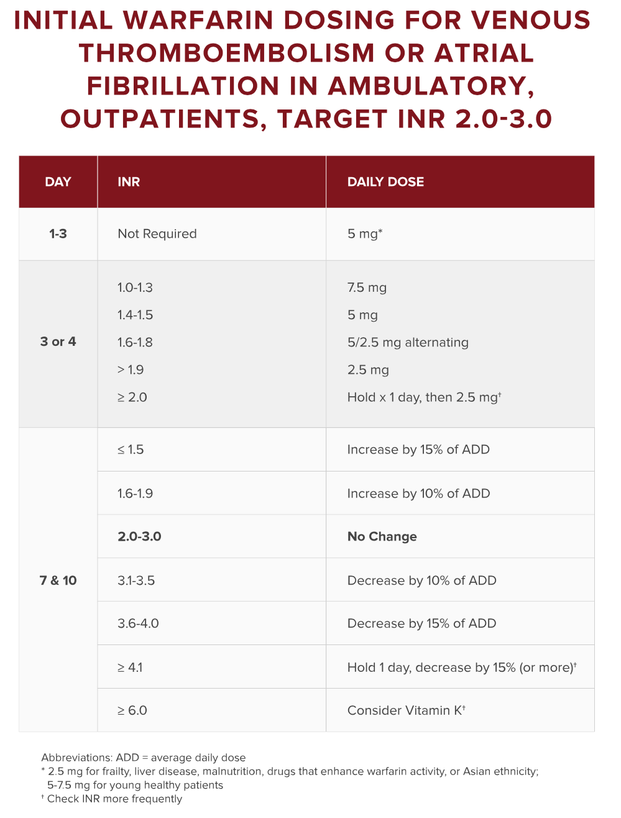

## Chronic Warfarin Dosing

* This nomogram is suggested for non-bleeding patients with target INR 2.0-3.0 who are out of range and who are not at high risk of bleeding
* INR ≤ 2.0
  + Increase by 10-15%
    - Consider 15% increase if INR ≤ 1.5 without explanation
  + Repeat INR in one week
* INR 3.1 – 3.5
  + Consider noncompliance, illness, drug interaction, or dietary changes as reason for out-of-range INR
* INR 3.6 -4.0
  + Confirm no bleeding
  + Hold 0-1 dose, decrease by 10-15%
  + Repeat INR in 1 week
* INR 4.1 -8.9
  + Confirm no bleeding
  + Hold 0-2 doses, decrease by 10-15% +/- Vit K 2.5 mg PO

Repeat INR in 2 days

## Warfarin Reversal

### Overview

* Reversal
  + An INR greater than 4.0 has been a/w an increased risk of bleeding
    - The risk of intracranial hemorrhage increases approximately twofold for everyone one-unit increase of INR
    - Additional RFs for intracranial hemorrhage
      * Older age, EtOH use and presence of kidney failure
* Anticoagulation and Medical Procedures
  + For minor dental (tooth extraction), ophthalmologic (cataract surgery), and dermatologic procedures (SCC and BCC removal) that have a low risk of bleeding or risk of bleeding that can be controlled with local hemostatic methods (e.g. cautery) AC Tx can be continued without interruption
* For asymptomatic INR elevation, an INR of 9-10 is where you should intervene
* If you have a major bleed from warfarin overdose -> use KCENTRA
  + See Kcentra and prothrombin complexes (section below)

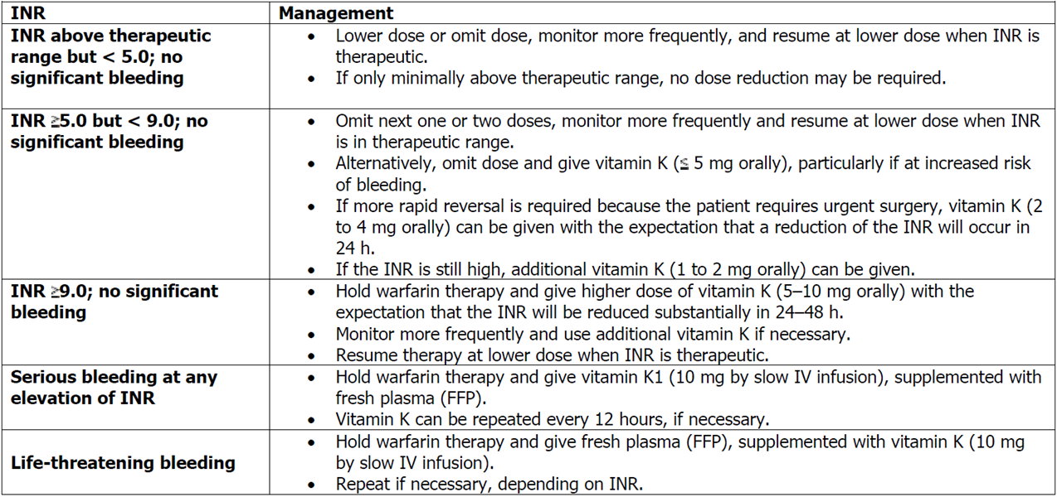

CHEST 2004 Ansell J 126:204S

# Prothrombin Complex Concentrates

## Overview

* Prothrombin complex concentrate (PCC) products are emerging as alternative strategies for reversing anticoagulant pharmacotherapy
* There are two majors PCCs: KCENTRA (a non-activated PCC) and FEIBA (an activated PCC)
* **F**actor **e**ight **i**nhibitor **b**ypassing **a**ctivity (FEIBA, or anti-inhibitor coagulant complex) is an activated PCC (aPCC)
* If you have a major bleed from warfarin overdose -> use KCENTRA

## Prothrombin Complex Concentrate

### Overview

* PCC is a combination of blood clotting **factors II, VII, IX and X, as well as protein C and S**
* It is prepared from fresh-frozen human blood plasma
* Used to be used for treatment of Hemophilia B (IX def)
* It is used to reverse the effects of oral anticoagulation therapy when bleeding occurs (e.g. in the brain or gut) requiring rapid action to accelerate coagulation
  + PCC reverses the effects of warfarin and other coumarin anti-coagulants and is used in cases of significant bleeding in patients with a coagulopathy (INR > 8.0, prolonged prothrombin time)
  + It is also used when such a patient must undergo an emergency operation treatment
  + Other indications include a deficiency of one of the included clotting factors, either congenital or due to liver disease, and hemophilia
  + We’ve used it in a patient with Factor X deficiency from amyloid
* **KCENTRA** is a four-factor Product
  + Also contains protein C, S, heparin and ATIII
  + KCENTRA is not activated PCC, FEIBA is

### Advantages

* The advantages of PCCs over FFP include no need for ABO matching or plasma thawing; further, a small volume can be given over a short period
  + Of note, Typically, a large volume of FFP (15 mg/kg) is required for administration, which may lead to transfusion-associated cardiopulmonary overload and other infusion reactions, such as acute lung injury
* In the U.S., three distinct classifications of PCC products are commercially available:
  + three-factor PCC products contain three coagulation factors (II, IX, and X)
  + four-factor PCC products contain four coagulation factors (II, VII, IX and X)
    - **KCENTRA** is a four-factor Product
  + activated PCC (aPCC) products contain four coagulation factors (in inactive and activated forms)

### Contraindications

#### DIC

* The package insert states that PCC is contraindicated in patients with **disseminated intravascular coagulation**, a pathological activation of coagulation, because giving clotting factors would only further fuel this process
* However, if the PCC is given because factor levels are low, it can restore normal coagulation

#### HIT

* As PCC products contain heparin, they are **contraindicated** in patients with ***heparin-induced thrombocytopenia***

## Activated PCC

### Overview

* AKA FEIBA - **F**actor **E**ight **I**nhibitor **B**ypassing **A**civity
* Possess activated factors
* Currently, only one aPCC product is available in the U.S
  + A freeze-dried sterile human plasma fraction with **f**actor **e**ight (VIII) **i**nhibitor **b**ypassing **a**ctivity (FEIBA)
  + The product is available as FEIBA NF (anti-inhibitor coagulant complex, nano-filtered) and as FEIBA VH (anti-inhibitor coagulant complex, vapor-heated), both made by Baxter
* FEIBA NF and VH are considered aPCC products because they contain mostly activated factor VII along with mainly non-activated factors II, IX, and X
* Although FEIBA is approved by the FDA to control spontaneous bleeding episodes and to prevent bleeding with surgical interventions in hemophilia A and hemophilia B patients with inhibitors to factor VIII, recent data have suggested that the product may be used off-label as an anticoagulant-reversal agent

### AEs

* Increased risk of clot compared to prothrombin complex

# Heparin

## Overview

## 

### Unfractionated versus Low-molecular-weight heparin

* UFH inhibits factor Xa and thrombin equally, whereas LMWH has greater activity against factor Xa
  + As thrombin is a larger molecule and thus it can’t wrap around it (or at least that’s what the figure
* The anticoagulant effects of LMWH are therefore monitored by measurement of the ability of plasma to inhibit factor Xa, which provides the anti-factor Xa heparin level

## Monitoring Heparin

### Overview

* Normally aPTT (here the range is 60-100)
* If the aPTT is prolonged at baseline
  + Xa
  + II
  + If aPTT is quite prolonged after heparin is added in patients with high baseline, don’t stop the heparin, monitoring CBC and heparin levels
  + There is no such thing as auto-anticoagulated!

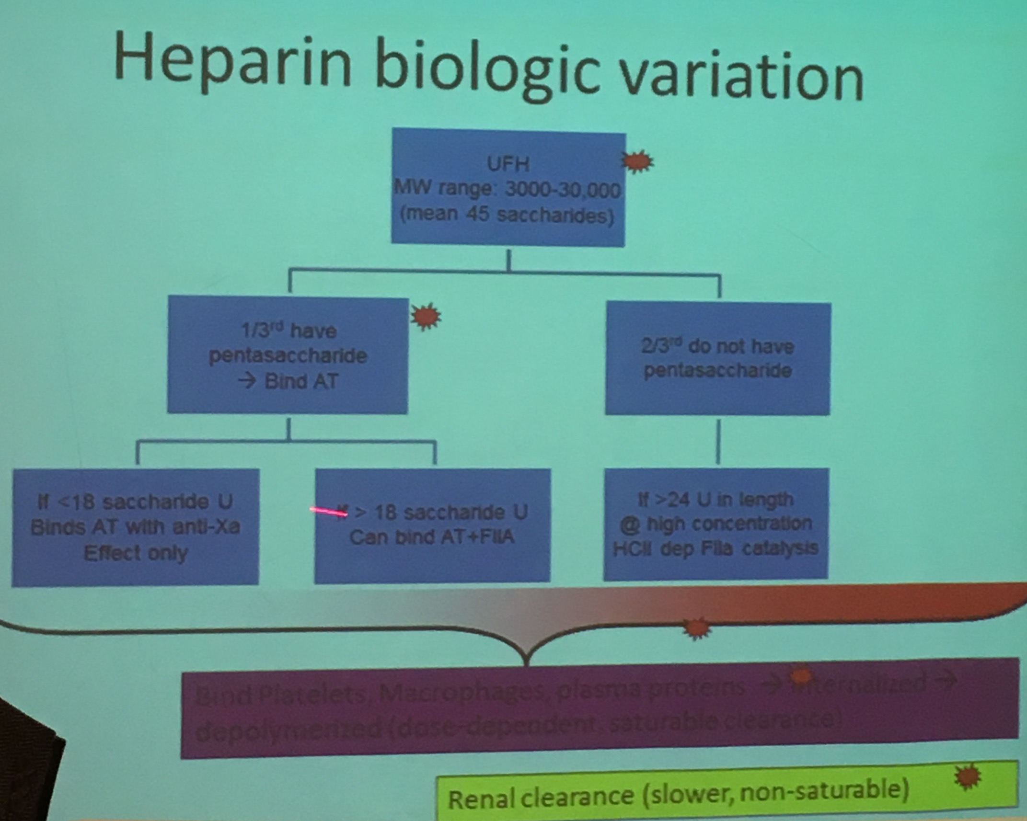

## Heparin Resistance

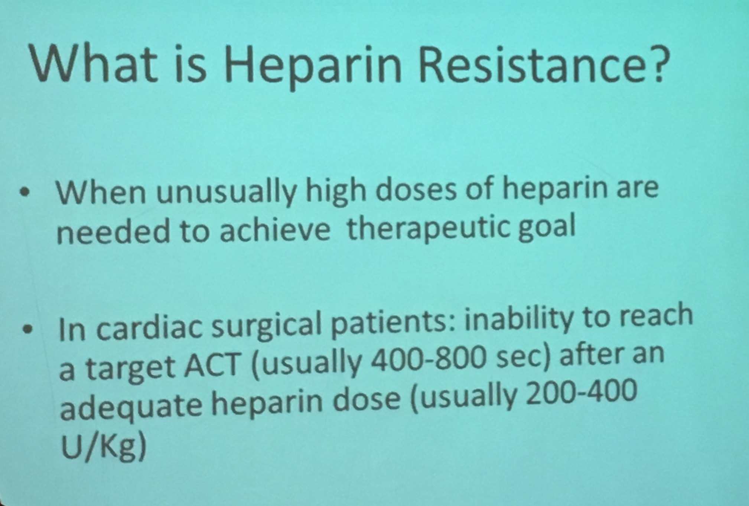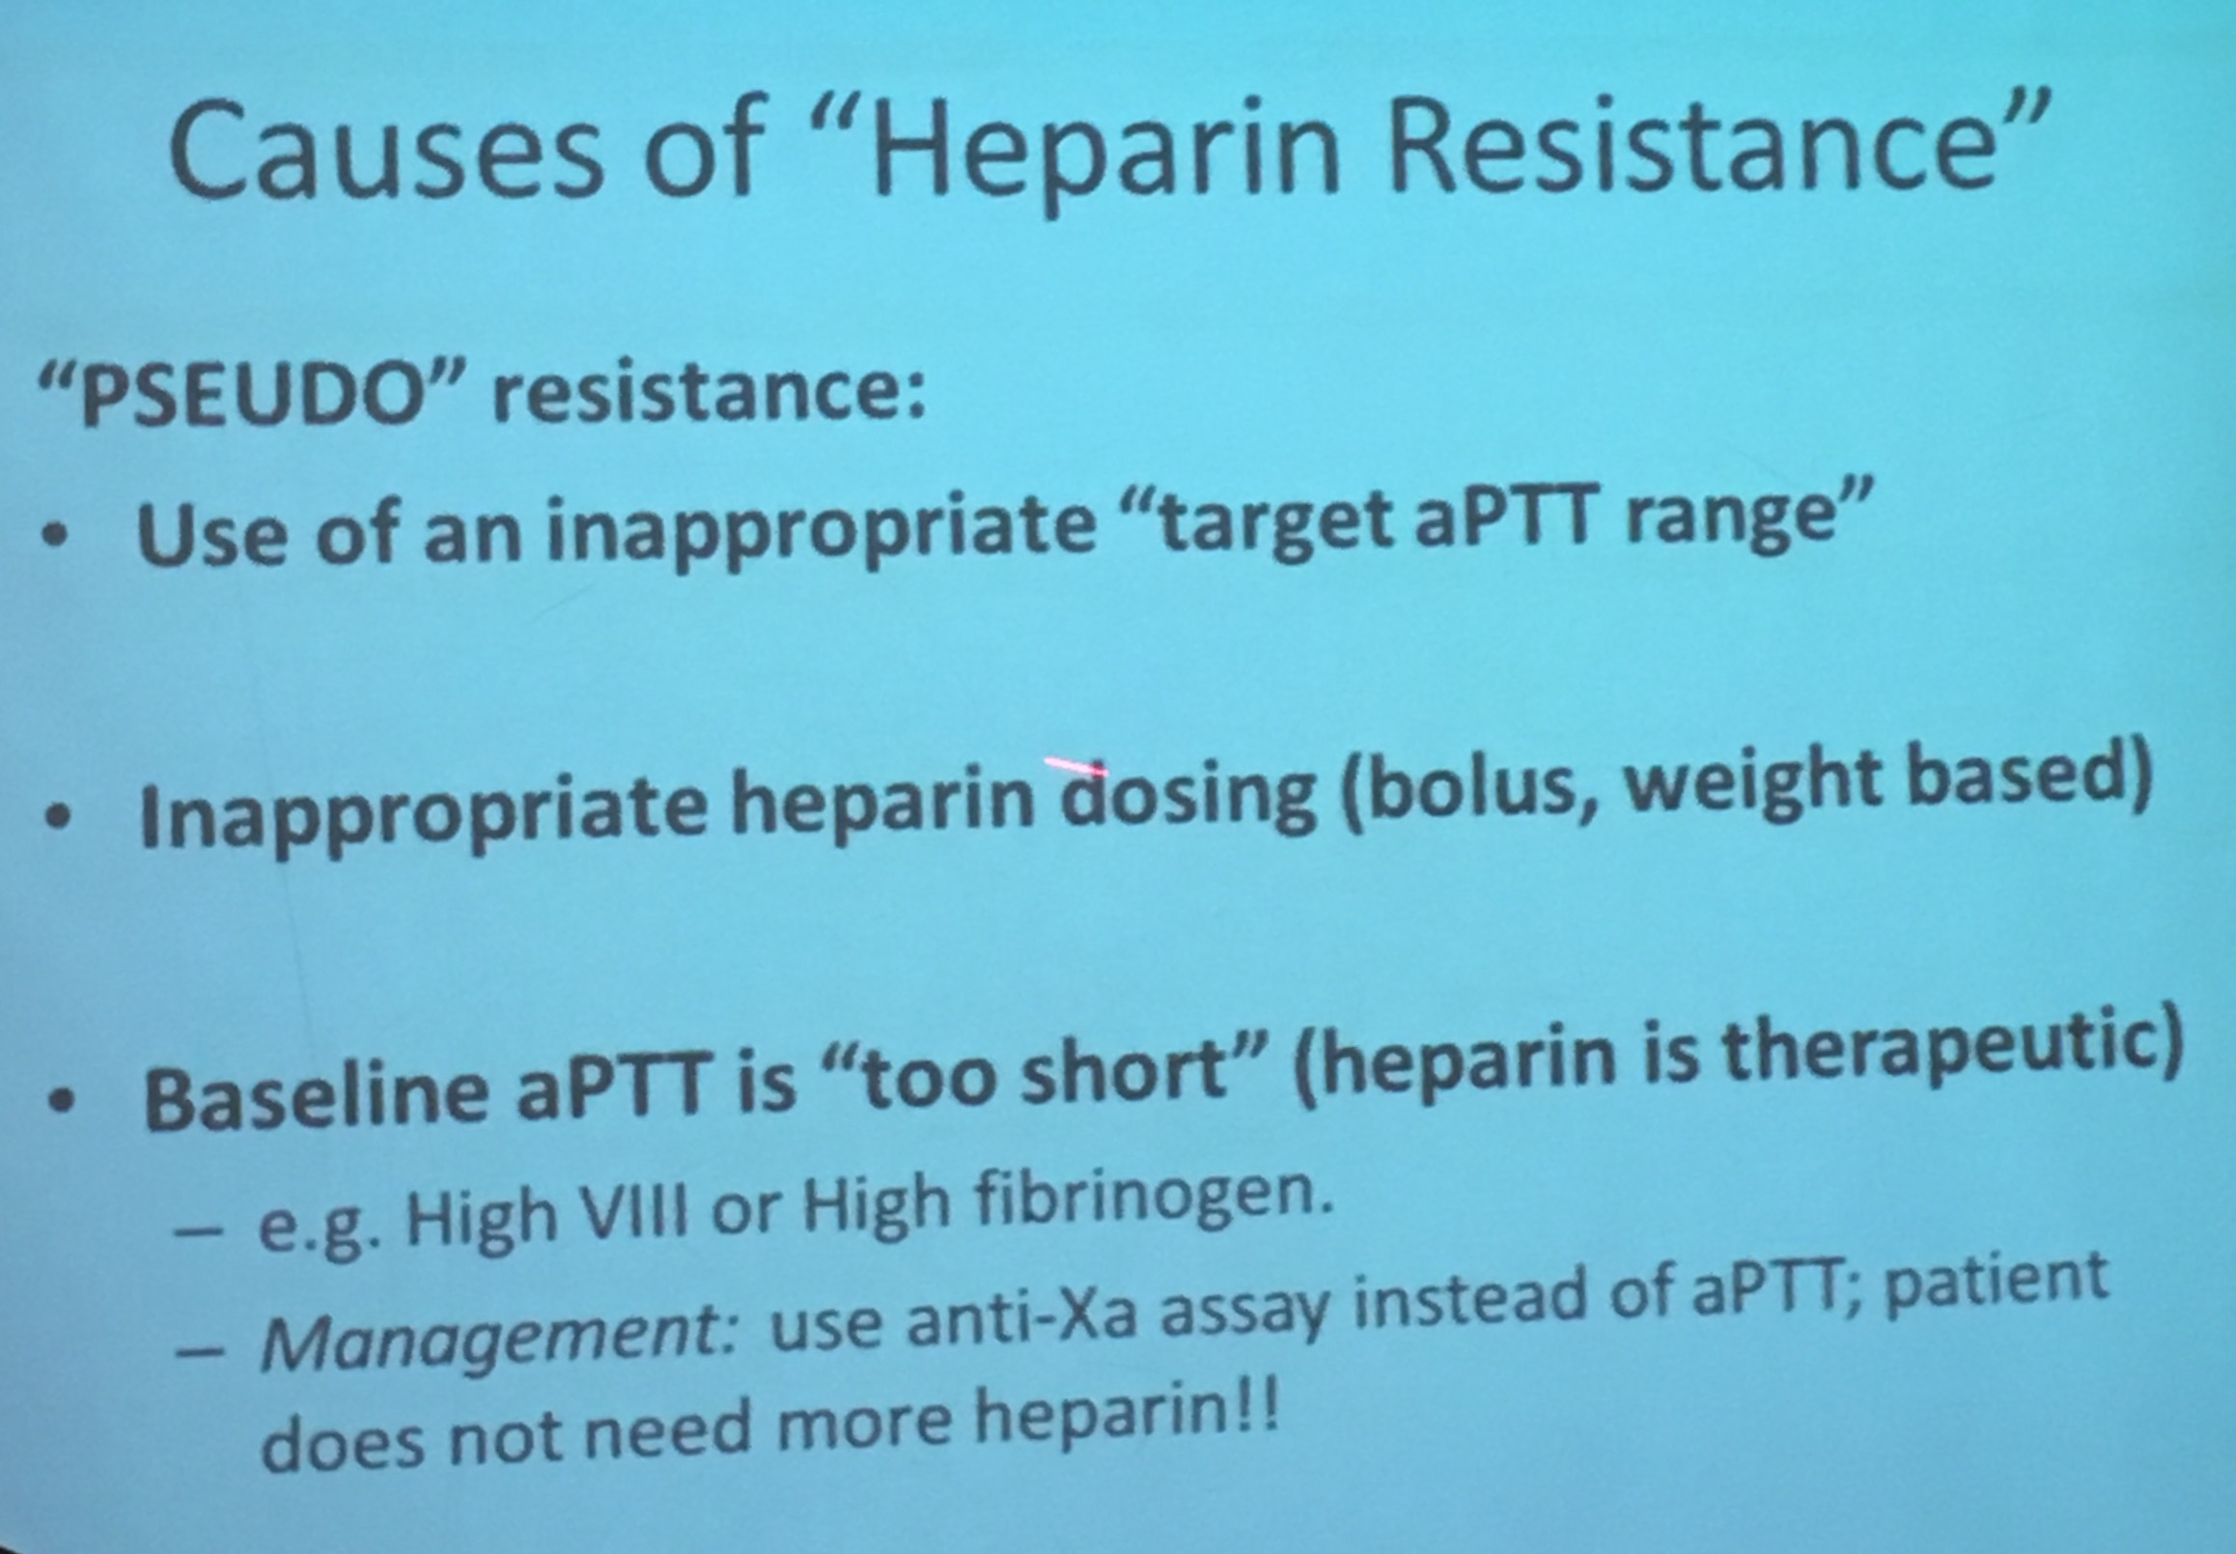

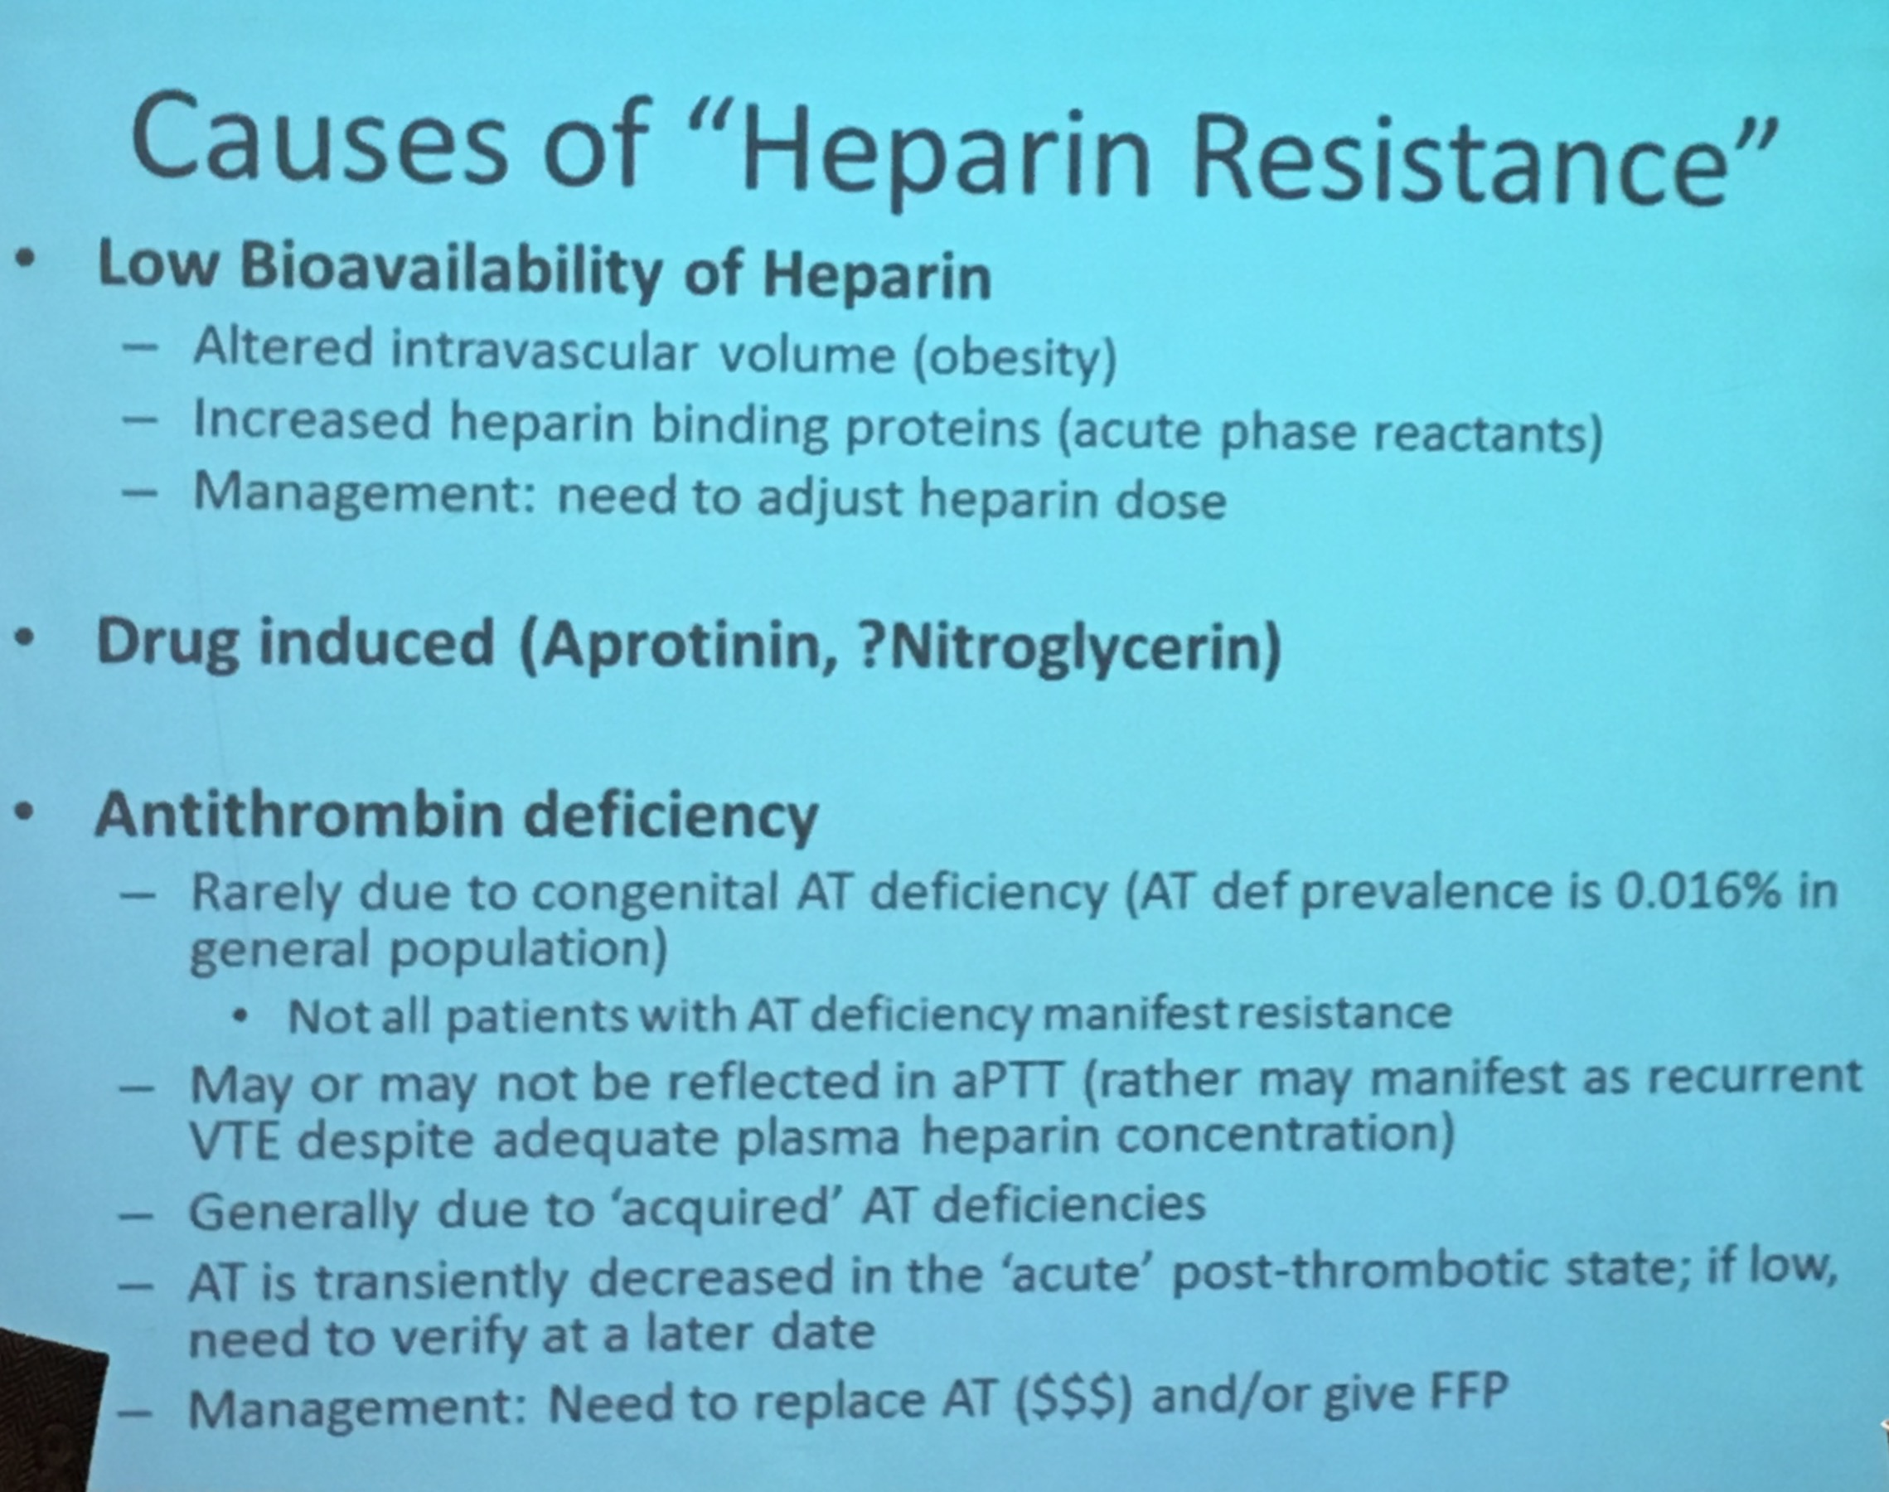

### Management

#### Overview

* Options depend in part on the cause
* If ATIII is the reason, you can give ATIII (thrombate)
* Alternatively you can use a Direct Thrombin Inhibitor
  + Bivalirudin is a reasonable option given that it can be used in patients with liver impairment (whereas argatroban is a little more sensitive to liver impairment)

#### Thrombate

* Recombinate ATIII
* Very expensive

## Heparin Infusion Using Anti-Xa Monitoring

### Provider-Managed Protocol - AntiXa Monitoring

* initiate therapy using recommended dosing based on clinical indication (see Heparin Infusion Guidelines)
* check AntiXa level (Heparin Activity level) 6 hours after starting infusion
* provider must order each dose adjustment - see algoithm below. NOT A NURSE-MANAGED ALGORITHM

|  |  |  |  |
| --- | --- | --- | --- |
| **SUGGESTED ALGORITHM FOR HEPARIN DOSING USING ANTI-Xa MONITORING**  NOT A NURSE-MANAGED ALGORITHM | | | |
| Heparin Activity (AntiXa) Level | PRN Re-Bolus | Change Infusion Rate | Next Heparin Activity (AntiXa) Level |
| < 0.20 units/ml | 25 units/kg once, | then increase by 4 units/kg/hr | 6 hours after dose adjustment |
| 0.20 - 0.29 units/ml | none | increase by 2 units/kg/hr | 6 hours after dose adjustment |
| 0.30 - 0.70 units/ml | none | No change | in 6 hours x 1, then qAM |
| 0.71 - 0.80 units/ml | none | decrease by 1 unit/kg/hr | 6 hours after dose adjustment |
| 0.81 - 0.99 units/ml | none | decrease by 2 units/kg/hr | 6 hours after dose adjustment |
| > 1.0 units/ml | none | Stop infusion for 1 hour,  then decrease by 3 units/kg/hr | 6 hours after dose adjustment |

# NoACs – Non-VKA Oral AntiCoagulant

## Overview

### Challenges with Warfarin

* + Delayed onset and offset
  + Drug-drug interactions
  + Food interactions
  + Genetics
  + Variable Dosing

### Properties of Ideal Long-Term Anticoagulant

* Oral
* Fast Onset and Offset
* Reversibility
* No food or drug interactions
* Predictable effects
* Extra-renal clearance

### Coagulation Cascade

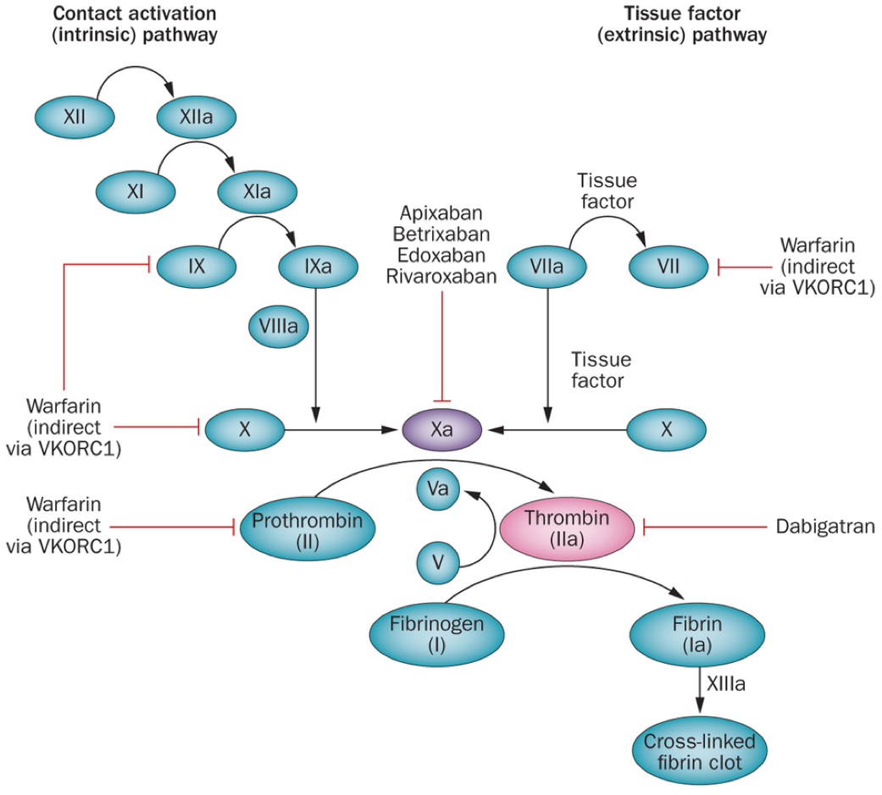





1. Of note, LMWH and UFH via effects on ATIII, inhibit Thrombin and Xa

## Overview of Atrial Fibrillation Management

### Epidemiology

* + The #1 preventable cause of stroke
    - Thrombus in LA appendage is most common mechanism
      * Tell your patients why your starting them on an anti-coag with Afib, b/c many patients don’t make the link
  + Up to 12-16 million will be affected by 2050

## Data for Anticoagulation in Atrial fibrillation

### Overview

* Warfarin
  + Meta analysis -> 60% reduction in stroke vs. placebo
* ASA
  + Taken out of guidelines in Europe
  + Some benefit, but not great
* TTR at the Brigham is ~65%
  + Time in therapeutic range
  + BWH is pretty good

### Dabigatran (Pradaxa) in AF

#### Data

* RE-LY Open label Trial Connolly NEJM 2009
  + Dabigatran vs. Warfarin (non inferior trial)
* In patients with atrial fibrillation, dabigatran given at a dose of 110 mg was associated with rates of stroke and systemic embolism that were similar to those associated with warfarin, as well as lower rates of major hemorrhage
  + 110 not available in US

#### Dosing

* Dabigatran 150 mg BID is the only dose approved
* Dabigatran administered at a dose of 150 mg, as compared with warfarin, was associated with lower rates of stroke and systemic embolism but similar rates of major hemorrhage

##### Renal Adjustment

* Is renally cleared, so not a great pick if a patient has renal insufficiency; that said there are dose adjustment; however….
  + The FDA made up a dose for CrCl 15-30 mL/min (75 mg BID); this was not studied in the trials, it was completely made up

### Rivaroxaban (Xarelto)

##### Overview

* Initial FDA action date on July 1, 2011 for prophylaxis of deep vein thrombosis and pulmonary embolism in patients undergoing: hip replacement surgery or knee replacement surgery

##### Indications

* To reduce the risk of stroke and systemic embolism in patients withv nonvalvular atrial fibrillation
* For the treatment of deep vein thrombosis (DVT)
* For the treatment of pulmonary embolism (PE)
* For the reduction in the risk of recurrence of DVT and/or PE in patients at continued risk for recurrent DVT and/or PE after completion of initial treatment lasting at least 6 months
* For the prophylaxis of DVT, which may lead to PE in patients undergoing knee or hip replacement surgery
* Rivaroxaban prolongs the PT more than PTT
  + Ken says that isolated PT in an 80 year old, all comers, is probably on Riva
  + Apixaban doesn’t prolong either
  + Dabigatran prolongs PTT more so than PT

##### Data

* ROCKET AF trial Patel et al NEJM 2011
  + Riva vs. Warfarin
    - TTR high 50s%
* In patients with atrial fibrillation, rivaroxaban was noninferior to warfarin for the prevention of stroke or systemic embolism
* There was no significant between-group difference in the risk of major bleeding, although intracranial and fatal bleeding occurred less frequently in the rivaroxaban group
* Metabolism
  + Rivaroxaban has a dual mode of elimination, with two-thirds of the dose being metabolized in the liver through oxidative and hydrolytic pathways catalysed via cytochrome P450 enzymes (CYP3A4, CYP2J2 and CYP-independent mechanisms), half of which is excreted via the kidneys and half via the faecal route
  + One-third of the dose is eliminated as unchanged drug in the urine

##### Dosing

###### Treatment of VTE

* Initial
  + 15 mg BID x 21 days
    - Of note, give the 15 mg and 20 mg tabs with food
      * Riva depends on the presence of food for optimal absorption
        + Not so with the 10 mg dose for VTE ppx

This can be taken with or without food

* After 21 days
  + 20 mg Daily with food for remainder

###### VTE Prophylaxis

* In nonvalvular AFib
  + 20 mg daily taken **with the evening meal** if CrCl >50 mL/min
  + 15 mg daily taken **with the evening meal** if CrCl 15-50 mL/min
* Following Hip Replacement
  + 10 mg daily for 35 days
    - Start 6-10 h post op once hemostasis established
* Following Knee Replacement
  + 10 mg daily for 12 days
    - Start 6-10 h post op once hemostasis established

###### Renal Dosing

* DVT/PE Tx
  + Avoid use if CrCl <30

##### Effect on the PT/PTT



### Apixaban (Eliquis)

#### Overview

* FDA action date 12/28/2012 to reduce the risk of stroke and systemic embolism in patients with nonvalvular atrial fibrillation
* ARISTOTLE Granger NEJM 2011
  + Apixaban vs. Warfarin
* In patients with atrial fibrillation, apixaban was superior to warfarin in preventing stroke or systemic embolism, caused less bleeding, and resulted in lower mortality
  + The home run of clinical trials (some consider)

#### Dosing

* 5 mg BID

##### Renal Adjustments

* No dose adjustment is necessary in patients with mild or moderate renal impairment
  + b/c it is only has 27% renal clearance
* In patients with severe renal impairment (creatinine clearance 15-29 mL/min) the following recommendations apply:
  + for the prevention of VTE in elective hip or knee replacement surgery (VTEp), for the treatment of DVT, treatment of PE and prevention of recurrent DVT and PE (VTEt) apixaban is to be used with caution
  + for the prevention of stroke and systemic embolism in patients with NVAF:
    - patients should receive the lower dose of apixaban 2.5 mg twice daily.
* patients with serum creatinine ≥ 1.5 mg/dL (133 micromole/L) associated with age ≥ 80 years or body weight ≤ 60 kg should also receive the lower dose of apixaban 2.5 mg twice daily
* In patients with creatinine clearance < 15 mL/min, or in patients undergoing dialysis, there is no clinical experience therefore apixaban is not recommended
  + That said, I have used 2.5mg BID in a patient on P

##### Effect on the PT/PTT

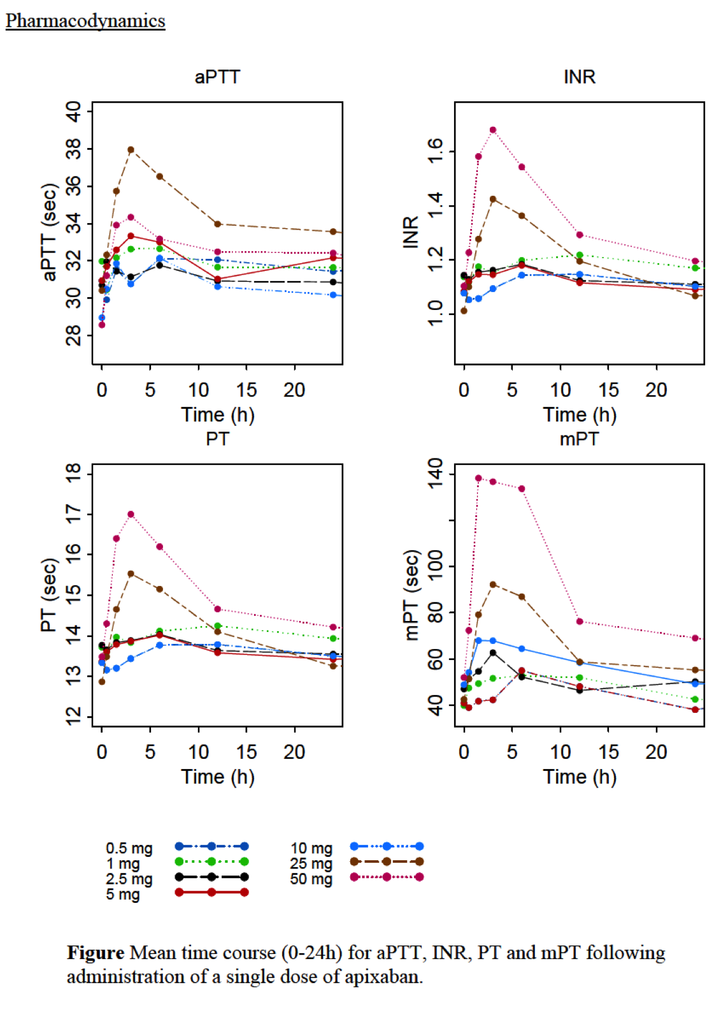

### Edoxaban (Lixiana)

#### Data in AF

* ENGAGE AF-TIMI 48 (Antman and other BWH investigators)
  + Edoxaban vs. Warfarin
* Both once-daily regimens of edoxaban were noninferior to warfarin with respect to the prevention of stroke or systemic embolism and were associated with significantly lower rates of bleeding and death from cardiovascular causes
* Of note, this study had the highest TTR (time in therapeutic range) (about 68%) for the warfarin group
* Raskob et al Lancet Haematol 2016
  + Active cancer, about 100 on each arm
  + HR 0.53
* Phase III study
  + Edox vs. Dalteparin
  + Study done here, results hopefully at ASH 2017

#### Dosing

* 60 g QD (CrCl 51-59 mL/min)

##### Renal Adjustments

* 30 mg QD (CrCl 15-50 mL/min)

### Mega’s Summary

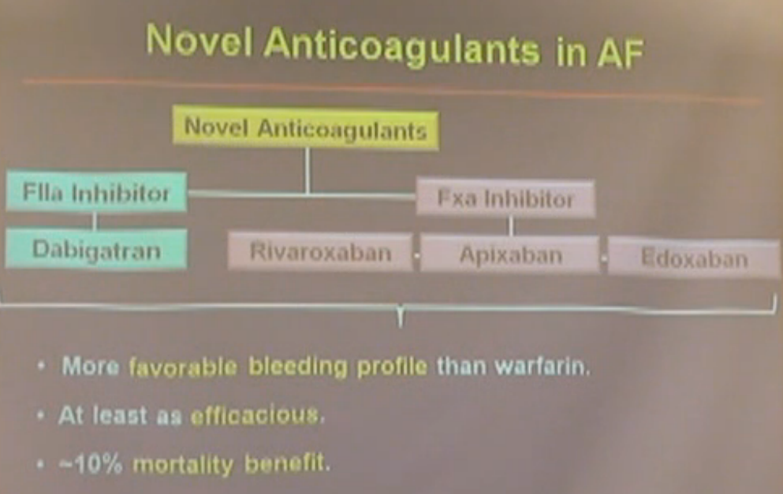

* Bleeding better for intracranial hemorrhage, but GI bleeding rates are not better
* Efficacy
  + As good, if not better
* Probably an overall mortality benefit
  + Likely 2/2 decrease bleeding risk
* Overall, she likes the Xa inhibitors a bit better than IIa
  + *Dabigatran can cause GI upset* (~20% of patients)

### Total Hip and Knee Replacements

* Enoxaparin vs. Rivaroxaban
  + Riva appears better in studies (meta analysis)

### VTE and PE

* EINSTEIN-DVT NEJM 2010 (Registration trial)
  + Rivaroxaban vs. Enoxaparin/VKA in patients with DVT for prevention of recurrence
    - Riva better than Enox
  + Recurrent VTE
    - Cancer 0.69
    - No cancer 0.93
  + Major bleeding
* EINSTEIN PE
  + Riva vs. Enox
    - Riva non-inferior to Enox for prevention of recurrence
    - Riva better for major bleeds reduction
    - No e/o liver toxicity

### ACS And Antithrombic Therapy

* ATLAS ACS2 TIMI 51
  + Placebo vs. Riva 2.5mg vs. Riva 5.0mg

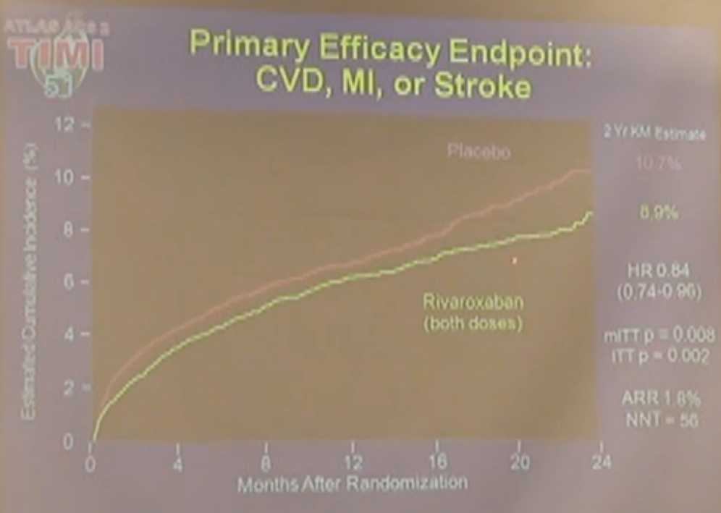

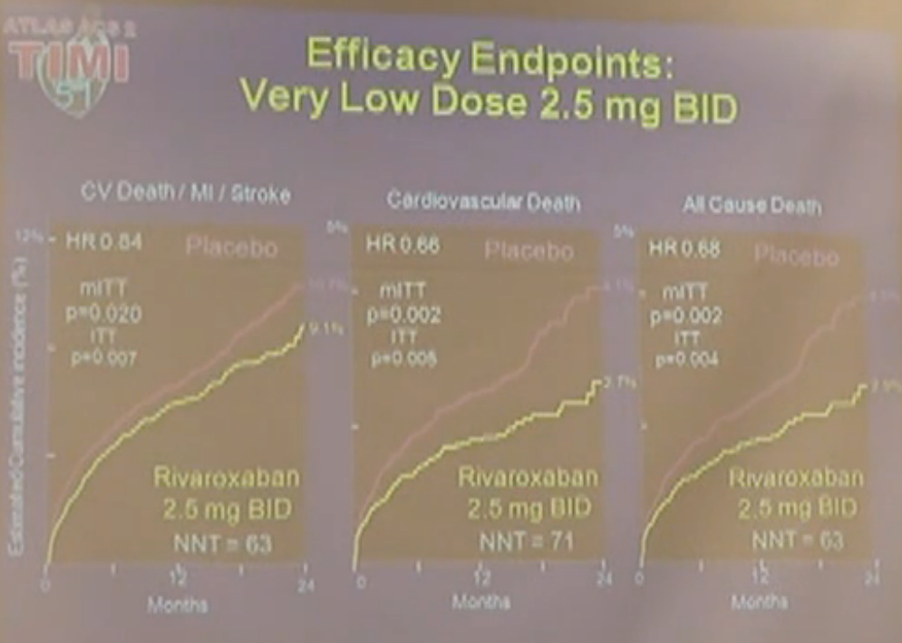

* + 1. Approved in Europe for ACS

### Data for NOACs in Cancer

* Two trials published in 2018 showed that **Xa inhibitors** were either non-inferior to LMWH (Hokusai trial; though all patients were started on LMWH first) or that Xa inhibitors were superior to LMWH (SELECT-D) trial

#### Data

##### SELECT-D Trial7

* Young et al JCO 2018

###### Summary

* Riva may be a reasonable choice in cancer patients with VTE, just use caution in patients with esophageal cancer and high risks of bleeding

###### Overview

* This was a relatively small pilot trial of 406 patients in the UK with active cancer, that had VTE/PE
* Allocation was to:
  + dalteparin
    - 200 IU/kg daily during month 1, then 150 IU/kg daily for months 2-6 or
  + rivaroxaban
    - 15 mg twice daily for 3 weeks, then 20 mg once daily for a total of 6 months
* The primary outcome was VTE recurrence **over 6 months**.
* Safety was assessed by major bleeding and clinically relevant nonmajor bleeding (CRNMB)
* 25% of patients had colorectal cancer
* 69% of patients were undergoing cancer treatment

###### Results

* A total of 203 patients were randomly assigned to each group, 58% of whom had metastases
* Twenty-six patients experienced recurrent VTE (dalteparin, n = 18; rivaroxaban, n = 8)
* The 6-month cumulative VTE recurrence rate was **11% with dalteparin** (95% CI, 7% to 16%) and 4% with rivaroxaban (95% CI, 2% to 9%)
  + **hazard ratio [HR], 0.43; 95% CI, 0.19 to 0.99**
* The 6-month cumulative rate of major bleeding was **4% for dalteparin** (95% CI, 2% to 9%) and **6% for rivaroxaban** (95% CI, 3% to 11%) (HR, 1.83; 95% CI, 0.68 to 4.96)
  + i.e. no difference
  + No CNS bleeds
  + There was a signal that cancer of the esophagus and gastroesophagus was associated with rivaroxaban-associated major bleeding
* Corresponding rates of CRNMB (non-major bleeding) were 4% (95% CI, 2% to 9%) and 13% (95% CI, 9% to 19%), respectively (HR, 3.76; 95% CI, 1.63 to 8.69)
  + A statistical difference
  + There was a three-fold relative increase in CRNMB with rivaroxaban compared with dalteparin
  + Such bleeds were not trivial, because they had to satisfy at least one of the following criteria: requiring medical intervention, unscheduled contact with a physician, interruption or discontinuation of study drug, or discomfort or impairment of activities of daily life



##### Hokusai Trial8

* Raskob et al NEJM 2018

###### Overview

* Edoxaban vs. dalteparin **non-inferiority trial**
* Patients with cancer and VTE were given **low-molecular-weight heparin for at least 5 days** **followed by oral edoxaban at a dose of 60 mg once daily** (edoxaban group) or **subcutaneous dalteparin** at a dose of 200 IU per kilogram of body weight once daily for 1 month followed by dalteparin at a dose of 150 IU per kilogram once daily (dalteparin group)
* Treatment was given for at least 6 months and up to 12 months
* The primary outcome was a **composite of recurrent venous thromboembolism or major bleeding** during the 12 months after randomization, regardless of treatment duration.

###### Results

* A primary-outcome event occurred in **12.8% in the edoxaban group** (67 of the 522 patients) as compared with **13.5% in the dalteparin group** (71 of the 524 patients)
  + Hazard ratio, 0.97; 95% confidence interval [CI], 0.70 to 1.36
  + P = 0.006 for noninferiority; P = 0.87 for superiority
* Recurrent venous thromboembolism occurred in 41 patients (7.9%) in the edoxaban group and in 59 patients (11.3%) in the dalteparin group (difference in risk, −3.4 percentage points; 95% CI, −7.0 to 0.2)
* Major bleeding occurred in 36 patients (6.9%) in the edoxaban group and in 21 patients (4.0%) in the dalteparin group (difference in risk, 2.9 per- centage points; 95% CI, 0.1 to 5.6).

 



#### Summary

* One of the reasons these patients do poorly with Warfarin, is that the TTR is low and it’s hard to keep in therapeutic range
  + Some argue that these patients didn’t fail warfarin, but failed warfarin management
  + E.g. 20/53 patients with VTE in CLOT trial in the OAC group had an INR <2.0

### Other Data with NOACs in Cancer

* Drug-Drug interactions can be a challenge
  + Many drugs, esp those P-gp inhibitors can require dose reduction for Edoxaparin
    - TKIs: imatinib, nilotinib, lapatinib, sunitinib
    - Hormonal agents: tamoxifen, enzulatamide, abiraterone
    - Immuno-modulating agents: cyclosporine, tacrolimus
* Rivaroxaban and AF in active Cancer
  + MSK Experience under a QI initiative
    - Laube et al Am J Cardiol 2017
  + Manta et al
    - 6 month risk of recurrent VTE: 4.4%, Major bleed 2.2%
    - non comparator study
  + Davies et al Thromb Res 2017
    - Riva to treat CVC thrombosis in cancer patients

## 

## Barrier to the use of NOACs and VKAs (Vit K antagonists)

* Still an underTx of patients (we need to tx more patients)
  + Why
    - Risk for Falls
      * Reality is that a patient has to fall about 295 times in one year for warfarin not to be the optima therapy

### Renal Dosing

#### Renal Clearance

* Dabigatran
  + 80% renally cleared
* Riva
  + 33% renally cleared
* Apixaban
  + 27% renal clearance
* Edoxaban
  + 50% renal clearance

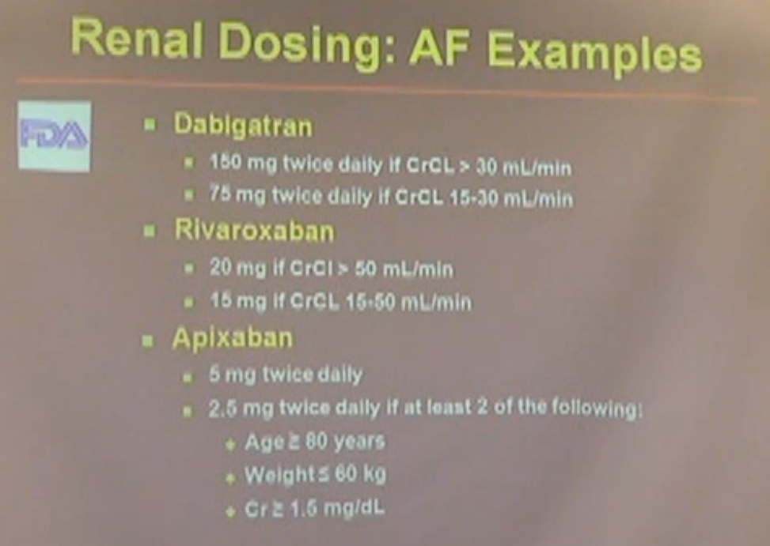

### Apixaban

* No dose adjustment is necessary in patients with mild or moderate renal impairment
  + b/c it is only has 27% renal clearance
* In patients with severe renal impairment (creatinine clearance 15-29 mL/min) the following recommendations apply:
  + for the prevention of VTE in elective hip or knee replacement surgery (VTEp), for the treatment of DVT, treatment of PE and prevention of recurrent DVT and PE (VTEt) apixaban is to be used with caution
  + for the prevention of stroke and systemic embolism in patients with NVAF:
    - patients should receive the lower dose of apixaban 2.5 mg twice daily.
* patients with serum creatinine ≥ 1.5 mg/dL (133 micromole/L) associated with age ≥ 80 years or body weight ≤ 60 kg should also receive the lower dose of apixaban 2.5 mg twice daily
* In patients with creatinine clearance < 15 mL/min, or in patients undergoing dialysis, there is no clinical experience therefore apixaban is not recommended
  + That said, I have used 2.5mg BID in a patient on PD

## Adverse Effects

* Dabi
  + GI
  + MI data shows may be not the best
  + BID dosing
* Riva
  + AF doses requires taking at night with food
* Apixaban
  + BID dosing
* Pregnancy
  + Bauer says don’t use in pregnancy

### When to be cautious or don’t use (per Bauer)

* Pregnancy
  + Never in pregnancy-associated VTE or post partum
* Massive PE
  + Where thrombolysis is a consideration
* Very obese or frail patients
  + Trials didn’t really examine PK/PD in extremes of body mass
  + >275-300 lbs or less than 100-110
* Renal dysfunction (creatinine clearance <30mL/min) or major drug-drug interactions
* Patients with altered GI anatomy (e.g. bypass)
* Cautious in “difficult” or highly prothrombotic patients
  + Recurrent VTE on established therapies such as warfarin or LMWH, APLS, active cancer, HIT

## NoACs vs. Warfarin

### Ischemic Strokes

* Warfarin is pretty good (about 70% effective), only dabigratran 150 mg is better
  + The others are similar

### Intracranial Hemorrhage

* NoACs are better than warfarin
  + Thought is b/c of the effects of warfarin on TF and Factor VII
    - The brain is bathed in Tissue Factor, and if you inhibit factor VII with warfarin, TF can’t due its function (which is act as a cofactor for FVII)
    - Thus if you have brain bleed and get a TF upregulation it will have some effect with a NoAC (b/d there down stream), but much less effect with warfarin

### Major Bleeding

* Epixaban and Edoxaban are statistically better at major bleeding than Warfarin

### GI Bleeding

#### Major GI Bleeding

* NoACs are worse than warfarin
  + as NoACs are active in the gut, where warfarin is not
    - thus if the NoACs are passing by a bleed in the GI tract it could make it worse
* Warfarin is inert in the GI tract

#### Life-Threatening or Fatal GI Bleeding

* Warfarin is worse than NoACs
* Possible explanation:
  + If you have a polyp or ulcer and you take a locally acting AC (like a NoAC), you’re more likely to present to clinic
    - But you’re not more likely to hemorrhage, lose 5 units and end up in the MICU

### Mortality Reduction

* 10% better for the NoACs than Warfarin

## Cost-Effectiveness

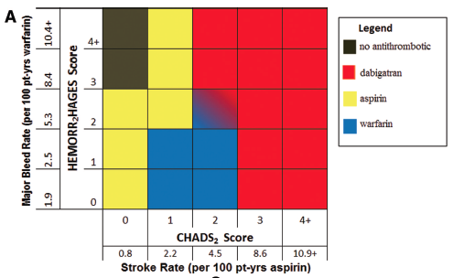

* + - Shah Circulation 2011
      * Cost-effectiveness threshold of $50,000 per quality adjusted life-year
    - NOAC is about $3000/year
    - Warfarin is about $50/year
* Measuring vs. Monitoring
  + Dabigatran
    - The dilute prothrombin time can be used to measure that a patient is on a drug
      * There is a correlation, but we don’t know what to do with that number
* Discontinuing NOACs prior to procedures
  + 1 day to 96 hours

## Reversal Agents

### Idarucizumab (PraxBind) for Dabigatran Reversal

* Basics
  + A monocolonal antibody fragment that binds Dabigatran
  + Acts like thrombin in binding Dabigatran, but doesn’t act like thrombin and does not promote clotting
* Data
  + RE-VERSE AD study N Engl J Med 2015; 373:511-520
    - Humanized mAb to Antibody fragment
    - Selectively and immediately neutralized dabigatran activity
    - 2.5g x 2 doses given 15 min apart
    - Read out
      * Dilute thrombin time and ecarin clotting time
    - Results
      * Drug completely reversed Ac in >90% of patients within 10-30 mins
      * Median tie to bleeding cessation was 11.4 hours
      * Normal hemostasis as judged by surgeon
* On October 16, 2015, the U. S. Food and Drug Administration granted accelerated approval to idarucizumab
* Bauer thinks Ida is a better reversal agent than Andexanet
* We have this at BIDMC, not sure if it’s in the ED at BIDMC

### Andexanet

* Basic
  + Now approved
  + A Decoy protein
    - Binds and sequesters factor Xa inhibitors (at andexanet’s active site)
  + Andexanet lacks a membrane-binding gamma carboxy-glutamic acid (GLA) domain and is catalytically inactive
    - Doesn’t bind to the membrane
    - Lacks pro or anti AC activity
  + Half life, 1 hour
    - As such, endogenous Xa is “free” to propagate clot formation
  + Given as a bolus, then continuous infusion
  + Works for all Xa inhibitors
  + Not a perfect drug
    - there are nuances based on the drug (b/c each drug has there own unique pharmacokinetics)
  + High dose regimen is 50k, but 25k for low dose
* Data
  + NEJM 2015
  + Anti-Xa levels seem to return to that of placebo after about two hours after last dose
    - 1 hour for Apixaban
    - 3 hours for Rivaroxaban
    - Which makes sense given that the half life is one hour
  + Thrombin generation returns to normal in a few minutes after andexanet is infused
  + Temporary increases in prothrombin fragment and D-dimer without thrombin generation
  + Thromboses rate was about 20%, could be prothromboti
* PER977
  + Cationic molecule that binds UFH, LMWH, DOAcs

## Managing Bleeding On A Noac

### Overview

* Below chart is a bit outdated
* Absorption blocker if relevant (i.e. activated charcoal if known O/D)
* If the appropriate reversal agent is available (i.e. Idarucizumab or Adnexanet), use it
* If you don’t have an antidote, Bauer would use **KCENTRA,** aPCC may be riskier since most patients on a Xa inhibitor already have a hypercoag state or at risk of clot (that’s why they are on it in the first place), so aPCC may be riskier
* Use an anti-fibrinolytic, such as tranexamic acid or Aminocaproic acid
* If bleeding persists after a dose of Idarucizumab, a second dose can be given

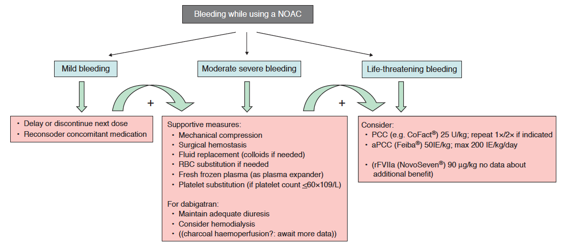

* + Heidbuchel Europace 2013 15, 625-651
    - IVF
    - Vit K does not work
    - FFP may provide a little
    - Protein Concentrates (CoFact) and NovoSeven are the best agents
      * These are prothrombotic
        + So be careful, only use if exsanguinating
* Prothrombin Concetrate Complex
  + Kcentra
    - Zahir 2014
      * Edoxaban and 4F-KCC in healthy study patietns
      * Some reduction/improvement in edoxaban-induced prolongation of PT
  + Take home
    - No studies in bleeding patietns
    - PCC are not great at reversing NoACs

**Conclusions**

1. Warfarin is a good drug and if patients are doing well on it, you don’t necessarily need to switch them
2. If measuring, reversibility and cost weren’t issues, the NOACs would probably be better choices

# Perioperative Management Of Anti-Coagulation

## Overview

* Surgical patients on chronic anticoagulant therapy confront the challenge of balancing their baseline thrombotic risk with the added thromboembolic and bleeding risks associated with invasive procedures
* Anticoagulation management must address the following:
  + (1) need for temporary anticoagulant cessation
  + (2) potential benefit of bridging anticoagulation if cessation is necessary
  + (3) appropriate timing for anticoagulant resumption after surgery

### Risk Stratifying

* Anticoagulation must be stopped for most surgical procedures except those with minimal expected blood loss (for example, cataract surgery, dermatologic procedures, dental procedures, and endoscopic procedures without biopsy)
  + For minor dental (tooth extraction), ophthalmologic (cataract surgery), and dermatologic procedures (SCC and BCC removal) that have a low risk of bleeding or risk of bleeding that can be controlled with local hemostatic methods (e.g. cautery) AC Tx can be continued without interruption
* If temporary cessation is warranted, therapy should be withheld for a sufficient period of time to leave minimal residual anticoagulant activity
* These categories correspond to an estimated annual thrombotic risk of
  + High: >10%
    - Individuals with mechanical mitral valves
    - atrial fibrillation and CHADS2 scores of 5 or 6
    - recent stroke
    - venous thromboembolism (VTE) within last 3 months
  + Moderate: 5%-10%
    - Bileaflet mechanical valves with Afib
    - Afib with CHADS2 of 3-4
    - Recurrent VTE or VTE within 3-12 months
  + Low: <5%
    - Those with atrial fibrillation and CHADS2 scores of 0-2
    - Bileaflet mechanical valves without Afib, CVA or other risk factors
    - Remote history of VTE more than 12 months before surgery and no other thrombotic risk factors

|  |  |  |
| --- | --- | --- |
| **Perioperative Warfarin Bridging Strategies** | | |
| **TE Risk (rate per year)** | **Patient Characteristics** | **Bridging Strategy** |
| Low (<5%) | Bileaflet mechanical **aortic valve** without atrial fibrillation, CVA, or other risk factors | No bridging |
|  | Atrial fibrillation with CHADS2 score ≤2 and no prior CVA | No bridging |
|  | VTE >12 mo previously with no other risk factors | No bridging |
| Intermediate (5%-10%) | Bileaflet mechanical aortic valve with atrial fibrillation or CHADS2 score >0 | Bridging on case-by-case basis; use therapeutic- or prophylactic-dosea LMWH or UFH |
|  | Atrial fibrillation with CHADS2 score 3-4 | Bridging on case-by-case basis; use therapeutic- or prophylactic-dosea LMWH or UFH |
|  | Recurrent VTE or VTE within past 3-12 mo or associated with nonsevere thrombophilia or active cancer | Bridging on case-by-case basis; use therapeutic- or prophylactic-dosea LMWH or UFH |
| High (>10%) | **Mitral** or caged ball or tilting disc mechanical aortic valve, or bileaflet mechanical aortic valve with recent CVA | Bridge with therapeutic LMWH or UFH |
|  | Atrial fibrillation with CHADS2 score >4, rheumatic valvular heart disease, or recent CVA or TIA | Bridge with therapeutic LMWH or UFH |
|  | VTE within past 3 mo or with severe thrombophilia | Bridge with therapeutic LMWH or UFH |

* CVA = cerebrovascular accident; LMWH = low-molecular-weight heparin; TE = thromboembolism; TIA = transient ischemic attack; UFH = unfractionated heparin; VTE = venous thromboembolism.
* aProphylactic-dose LMWH is only an option in patients with VTE as their indication for chronic anticoagulation.
* Adapted from Douketis JD, Spyropoulos AC, Spencer FA, et al. Perioperative management of antithrombotic therapy: Antithrombotic Therapy and Prevention of Thrombosis, 9th ed: American College of Chest Physicians Evidence-Based Clinical Practice Guidelines. Chest. 2012;141(2 suppl):e326S-e350S. [PMID: 22315266](http://www.ncbi.nlm.nih.gov/pubmed/22315266)

## Transitioning from Warfarin

* Bridging anticoagulation with therapeutic-dose LMWH or unfractionated heparin (UFH) may be considered depending on the patient’s risk of TE
* In patients requiring minor dental procedures, warfarin may be continued with coadministration of an oral antifibrinolytic agent or warfarin may be stopped 2-3 days before the procedure
* Warfarin also may be continued in patients undergoing minor dermatologic procedures with the use of adjunctive local hemostatic measures as necessary
* Cataract surgery also may be performed without interruption of warfarin
* Like warfarin, the new oral anticoagulants, dabigatran, rivaroxaban, and apixaban, must be discontinued before major surgery
* Perioperative bridging protocols with these agents have been proposed based on pharmacokinetic data but have not been investigated systematically



* **Stopping warfarin 5 days prior to surgery usually achieves the standard target of an INR of less than 1.5.**
* Reversal
  + Rapid reversal of warfarin for urgent surgery can be accomplished with vitamin K, fresh frozen plasma, or prothrombin complex concentrates, but the potential thrombotic complications of this approach must be considered.

## Bridging Patients on Warfarin

* For patients chronically taking warfarin, the decision to provide alternative anticoagulation while off this drug is based upon the indication for chronic anticoagulation and level of thromboembolic risk (Table 84).
* Low Risk
  + For patients with low thromboembolic risk, warfarin therapy is stopped with no bridging anticoagulation
* High-risk
  + whereas high-risk patients should receive bridging anticoagulation with intravenous unfractionated heparin (UFH) or therapeutic-dose low-molecular-weight heparin (LMWH)
* Risk Stratifying
  + For all other patients, the decision for bridging is individualized based on patient and surgical considerations
  + Although the CHA2DS2-VASc risk score is the preferred method for long-term thromboembolic risk stratification in atrial fibrillation patients, its utility for perioperative risk stratification is unknown, and current ACCP guidelines for perioperative anticoagulation management utilize the CHADS2 system for perioperative risk stratification
* Heparin
  + LMWH should be avoided in patients with an estimated glomerular filtration rate <30 mL/min/1.73 m2.
  + If bridging is utilized, UFH or LMWH should be **started approximately 36 hours after** the last dose of warfarin
  + In patients receiving bridging with **UFH**, the last presurgical dose should be **4 to 6 hours before surgery**
  + In those being bridged with **LMWH**, the last dose should be given ***no sooner than 12 hours before surgery***if being dosed at **prophylactic** levels, or ***no sooner than 24 hours*** if being given at **therapeutic** dosing levels.
* **Bridging with LMWH in a high risk patient**
  + Plan to stop warfarin 5 days b/f surgery and switch to LMWH 4 days prior to the surgery
    - E.g. if surgery is on Aug 19, stop warfarin on Aug 14 and start lovenox BID on Aug15
    - i.e. Warfarin should be held 24 hours prior to transition to LMWH
  + The last preoperative dose should be administered the AM of the day b/f
    - i.e. Given on the AM of Aug 18, but held on the evening of Aug 18
  + Assuming adequate hemostasis, start enox BID and warfarin 24 hours after surgery
  + Overlap enoxaparin and warfarin for at least 5 days and until the INR is 2.0

## Peri-operative management of NoACs

* Much less data are available for the perioperative management of target-specific oral anticoagulants
* Most experts recommend a conservative approach to ensure elimination by the time of surgery

|  |  |  |  |
| --- | --- | --- | --- |
| **Cessation of Target-Specific Oral Anticoagulants Before Surgery** | | | |
|  | **Duration of Preoperative Cessation by Kidney Functiona** | | |
| **Agent** | **eGFR >50 mL/min/1.73 m2** | **eGFR 31-50 mL/min/1.73 m2** | **eGFR ≤30 mL/min/1.73 m2** |
| Apixaban | 1-2 d | 2-3 d | >3 d |
| Rivaroxaban | 1-2 d | 1-2 d | 2-3 d |
| Dabigatran | 1-2 d | 2-4 d | >4 d |

* eGFR = estimated glomerular filtration rate.
* aFor surgeries with high bleeding risk, use longer duration. All target-specific oral anticoagulants should not be restarted postoperatively until 24 hours after low bleeding risk surgery and 48 to 72 hours after high bleeding risk procedures.
  + Although normal activated partial thromboplastin time (aPTT) in patients taking dabigatran and normal INR in patients taking apixaban or rivaroxaban correlate with minimal residual activity, such testing is not routinely recommended
  + Riva’s half life is about 9 hours
* Reversal
  + There are no approved reversal strategies for these agents.
  + Rapid reversal of warfarin for urgent surgery can be accomplished with vitamin K, fresh frozen plasma, or prothrombin complex concentrates, but the potential thrombotic complications of this approach must be considered
* To test for Rivaroxaban activity
  + Anti-Xa levels are the best test
  + PT will also be elevated likely
  + PTT less so
* To test for Dabi activity
  + PTT is prolonged more than PT (for reasons that I don’t understand)

## Restarting Anticoagulation

### Warfarin

* Warfarin can be safely restarted 12 to 24 hours after surgery if there are no major bleeding concerns

### Heparin

* Therapeutic-dose LMWH and UFH may be started 24 hours after surgery with low operative blood loss (<500 mL) but should be withheld for at least 48 to 72 hours after surgery with greater blood loss
  + In the latter situation, it may be advisable to provide prophylactic-dose LMWH (which can be resumed within 12 hours after surgery) until therapeutic doses are possible.

### NoACs

* Dabigatran, rivaroxaban, and apixaban all have rapid onset of action and should be restarted using the same guidelines as LMWH.

## Managing patients with fluctuating INRs

* **Daily low dose Vit K**
  + In 2007, a double-blind randomized trial compared the effects of low-dose vitamin K (100-150 µg/d) and placebo on INR stability in 70 patients receiving chronic warfarin therapy.
  + Vitamin K supplementation resulted in 19 of 35 patients achieving the predefined criteria for stable control of anticoagulation compared with only 7 of 35 patients receiving placebo
    - It was hypothesized that low-dose vitamin K reduced the day-to-day variation in dietary vitamin K intake in patients with unexplained INR fluctuations.
  + Thus, *In some patients with fluctuating INRs while taking warfarin, daily supplementation with low-dose vitamin K (100-150 µg/d) can stabilize the INR*.
* Polymorphisms in the genes transcribing enzymes involved in the metabolism of vitamin K antagonists, such as cytochrome P-450 2C9 and vitamin K epoxide reductase complex-1, contribute to the variability in dose requirements among patients but do not explain day-to-day or week-to-week INR fluctuations in individual patients.
  + Therefore, genetic testing would not be helpful in this situation

## Management of Antiplatelets

* In general, patients may remain on aspirin for minor dental or dermatologic procedures and cataract surgery
* For major noncardiac surgery, those at low risk of cardiovascular events should discontinue aspirin *7-10 days before surgery*
  + Aspirin should be *continued* in patients judged to be at *moderate or high risk*.
* Patients who require coronary artery bypass grafting (CABG) should remain on aspirin in the perioperative setting
  + If such patients are on dual antiplatelet therapy, clopidogrel or prasugrel should be held beginning 5 days before surgery
* DAPT in setting of a stent
  + In patients with a coronary stent who are receiving dual antiplatelet therapy and require surgery, surgery should be deferred, if possible, during the period of highest risk for in- stent thrombosis (*6 weeks after placement of bare metal stents, 6 months after placement of drug-eluting stents*) (ASH)
    - After this period has passed, clopidogrel or prasugrel may be suspended temporarily for surgery
    - If surgery cannot be delayed, dual antiplatelet therapy should be continued during and after surgery
  + ACP Recommendations
    - In patients with CAD on dual antiplatelet therapy with aspirin and another agent (clopidogrel, ticagrelor, ticlopidine, or prasugrel), **neither should be stopped within 12 months of drug-eluting stent placement or 4 to 6 weeks of bare metal stent placement**
    - If a patient requires surgery during these intervals, dual antiplatelet therapy, or at least aspirin alone, should be continued perioperatively
    - Following these time periods (i.e after 12 months for DES), the non-aspirin antiplatelet can be temporarily **discontinued 5 to 7 days before surgery**, but **aspirin should be continued** uninterrupted unless the risk of surgical bleeding is excessive (such as intracranial surgery)

**Assessing Bleeding Risk**

* History
  + The history should include a detailed personal history of
    - Abnormal bleeding
    - Response to prior hemostatic challenges,
      * such as surgeries, trauma, and childbirth; and
    - Comorbidities or use of medications that could affect hemostasis
  + Patients should be queried specifically about common procedures, such as
    - tooth extraction and tonsillectomy,
      * which they may not think to mention unless prompted
  + Other questions
    - Have you ever received a blood transfusion
    - Have you ever needed iron replacement
* Pre-op Tests
  + PT, PTT, platelet count
    - Although high-level evidence is lacking, a fibrinogen of at least 100 mg/dL and a platelet count of at least 50 x 109/L is desired for moderate- to high- risk procedures
    - For neurosurgery and ophthalmologic procedures, it often is prudent to target a platelet count of at least 100 x 109/L
  + Hemostatic laboratory testing is neither cost effective nor informative in patients without a history suggestive of a bleeding disorder

# Transition of Anticoagulants









* Type O blood has on average about 25-30% lowering von willebrand factor

# References

1. Knoll, G.A.*, et al.* Thrombophilia and the risk for hemodialysis vascular access thrombosis. *J Am Soc Nephrol* **16**, 1108-1114 (2005).

2. Crowther, M.A.*, et al.* Low-intensity warfarin is ineffective for the prevention of PTFE graft failure in patients on hemodialysis: a randomized controlled trial. *J Am Soc Nephrol* **13**, 2331-2337 (2002).

3. Himmelfarb, J. & Couper, L. Dipyridamole inhibits PDGF- and bFGF-induced vascular smooth muscle cell proliferation. *Kidney Int* **52**, 1671-1677 (1997).

4. Sreedhara, R., Himmelfarb, J., Lazarus, J.M. & Hakim, R.M. Anti-platelet therapy in graft thrombosis: results of a prospective, randomized, double-blind study. *Kidney Int* **45**, 1477-1483 (1994).

5. Dixon, B.S.*, et al.* Effect of dipyridamole plus aspirin on hemodialysis graft patency. *N Engl J Med* **360**, 2191-2201 (2009).

6. Kaufman, J.S.*, et al.* Randomized controlled trial of clopidogrel plus aspirin to prevent hemodialysis access graft thrombosis. *J Am Soc Nephrol* **14**, 2313-2321 (2003).

7. Young, A.M.*, et al.* Comparison of an Oral Factor Xa Inhibitor With Low Molecular Weight Heparin in Patients With Cancer With Venous Thromboembolism: Results of a Randomized Trial (SELECT-D). *J Clin Oncol* **36**, 2017-2023 (2018).

8. Raskob, G.E.*, et al.* Edoxaban for the Treatment of Cancer-Associated Venous Thromboembolism. *N Engl J Med* **378**, 615-624 (2018).